Performance Testing Report: Server-Side & User Interface
Content
Introduction & Objectives 4
Testing environment 4
Testing scenario 5
Capacity test 6
1. Purpose of the test 6
2. Summary of Results 6
2.1 Saturation point and instability point 8
2.1.1 Saturation Point and resources 8
2.1.2 Instability Point and behavior under load 9
2.2 Service Level Agreements (SLA) Definition 10
2.3 Conclusions and Areas of Concern 11
3. Load Profile 12
3.1. Test Scenario Configuration Parameters 12
3.2. Actual Load Profile 13
4. Test Start and End Date/Time 14
5. Link to the Test HTML Reports 14
6. Detailed results 14
6.1 Capacity Test Analysis: Throughput, Response Time and Errors vs. Load 14
6.1.1 Expected behavior 14
6.1.2 Key observations: JMeter 14
6.1.3 Key observations: Gatling 15
6.1.4 Conclusion 16
6.2 Response time per transaction 16
6.3 Errors per transaction 17
6.4 Technical causes of instability and their correlation with metrics 19
6.4.1 CPU utilization 19
6.4.2 Memory utilization and paging 22
6.4.3 Disk and network 24
6.4.4 Load generator health 25
6.4.5 Conclusion 25
7. Capacity test conclusion 26
Response time test 26
1. Purpose of the test 26
2. Summary of Results 26
2.1 Response Time Analysis and Resource Utilization 27
2.1.1 Response Time Analysis 27
2.1.2 Resource Utilization 29
2.2 Service Level Agreements (SLA) Definition 30
2.3 Conclusions and Areas of Concern 31
3. Load Profile 32
4. Test Start and End Date/Time 32
5. Link to the Test HTML Reports 32
6. Detailed results 33
6.1 Response Time Behavior 34
6.2 Throughput Behavior 35
6.3 Conclusions 37
6.4 System Resource Utilization 37
6.4.1 CPU utilization 37
6.4.2 Memory utilization and paging 39
6.4.3 Disk and network 41
6.4.4 Load generator health 42
6.4.5 Conclusion 43
7. Response time test conclusion 43
Stability time test 44
1. Purpose of the test 44
2. Summary of Results 44
2.1 Metrics Analysis and Resource Utilization 44
2.1.1 Metrics Analysis 44
2.1.2 Resource Utilization 47
2.2 Service Level Agreements (SLA) Definition 49
2.3 Conclusions and Areas of Concern 50
3. Load Profile 50
4. Test Start and End Date/Time 51
5. Link to the Test HTML Reports 51
6. Detailed results 51
6.1 Response Time Behavior 52
6.2 Throughput Behavior 54
6.3 Conclusions 55
6.4 System Resource Utilization 56
6.4.1 CPU utilization 56
6.4.2 Memory utilization and paging 58
6.4.3 Disk and network 59
6.4.4 Load generator health 60
6.4.5 Conclusion 61
7. Stability test conclusion 61
UI test 62
1. Purpose of the test 62
2. Summary of Results 62
2.1 Client-Side Performance Metrics (Web Vitals) 62
2.2 Service Level Agreements (SLA) Definition 63
2.3 Conclusions and Areas of Concern 63
3. Load Profile 64
4. Test Start and End Date/Time 64
5. Link to the Test HTML Reports 64
6. Detailed results 64
6.1 Web Vitals Summary over all runs 64
6.1.1 LCP and FCP by loop 65
6.1.2 TBT, CLS, Speed Index and performance score 65
6.1.3 Conclusion 65
6.2 Load generator host monitoring 66
6.2.1 CPU utilization 66
6.2.2 Memory utilization and paging 66
6.2.3 Disk and network 67
6.2.4 Load generator health: test processes 67
6.2.5 Conclusion 68
7. UI test conclusion 68
Recommendations for Fixes, Improvements, and Investigation 69
1. PHP-FPM and Web Server (Nginx / Apache) Optimization 69
2. Caching and Database Optimization (WooCommerce / WordPress) 69
3. Application-Level Profiling (Home Page and Checkout) 69
4. Further Investigation and Infrastructure Monitoring 70
5. Frontend Performance and UI Diagnostics 70
Conclusion 72

Introduction & Objectives
This report provides a comprehensive performance analysis of both the backend and user interface (UI) systems as part of the Performance Testing Essentials program. The objective of this evaluation is to establish baseline performance metrics, identify saturation points, validate long-term stability, and pinpoint system bottlenecks across critical business workflows under various load profiles.
The testing scope encompasses:
- Backend Capacity Testing: Determining the system’s saturation point and peak throughput capabilities using both JMeter and Gatling.
- Backend Response Time Testing: Evaluating backend latency and behavior under a sustained load equivalent to 80% of the saturation point over a 30-minute window.
- Long-Term Stability Testing: Assessing system reliability, resource retention (RAM/CPU), and performance consistency over an extended 4-hour execution period.
- Client-Side (UI) Performance Testing: Measuring frontend execution, core web vitals, and user experience metrics across multiple runs (3–10 cycles) using Lighthouse.

Testing environment
• Server Infrastructure & Hardware Configuration:
Testing was conducted on a dedicated test host running the Windows OS with the following hardware specifications:
Central Processing Unit (CPU): AMD Ryzen (1 socket, 6 physical cores, 12 logical processors) with a base clock frequency of 2.30 GHz.
Total RAM: 32 GB (27.8 GB usable by the operating system, 4.2 GB hardware reserved).
Resource Allocation: Application services operated within allocated system limits with dynamic distribution of CPU computing power and system memory.
• Horizontal Pod Autoscaling (HPA):
Disabled (all load tests were executed on a single host machine to establish raw single-node capacity).
• JVM Heap & Garbage Collection:
Dynamic memory allocation was configured for backend application services according to standard environment limits. The JVM Heap Memory Usage telemetry showed stable heap utilization with timely Garbage Collection (GC) sweeps during traffic ramp-up phases.
• Load Generators:
Load generation was performed using dedicated instances of JMeter and Gatling configured to execute structured scenarios. Depending on the test type, the generators either scaled virtual users and active threads progressively to reach system capacity and saturation points, or maintained a steady, controlled transaction volume (such as the 80% load profile and 4-hour endurance test) to evaluate long-term performance and stability.

Testing scenario
Base Path for 100% of Users (Mandatory Steps):
- Opening the Application: Navigating to the homepage (GET /) — 100% of users.
- Navigating to the Tables Catalog: Clicking on the "Tables" tab (GET /tables) — 100%.
- Viewing a Table Product Page: Opening a random table product (GET /products/{TABLE_SLUG}/) — 100%.
- Adding a Table to the Cart: Executing an AJAX request to add the item (POST /wp-admin/admin-ajax.php) — 100%.
Branching with Chair Addition (50% of Users):
After adding the table to the cart, user threads are split evenly in half (50 / 50):
50% of users skip this stage and proceed directly to the merge point before cart checkout.
50% of users continue the path:
05. Navigating to the chairs tab (GET /chairs).
06. Opening a random chair product page (GET /products/{CHAIR_SLUG}/).
07. Adding it to the cart (POST /wp-admin/admin-ajax.php with updated cart contents).
Final Stage — Order Checkout (30% of Total Users):
Regardless of whether users added chairs to the cart, a total of 30% of all test participants execute the purchase transaction:
08. Opening the Cart: (GET /cart/) — 30%.
09. Proceeding to Checkout: Checkout page (GET /checkout/) — 30%.
10. Country Selection and Dynamic AJAX Request (chooseCountry / ic_state_dropdown) — 30%:
Executing a POST request to admin-ajax.php with the action parameter action=ic_state_dropdown.
Selecting a country by its code (country_code).
Optional extraction and saving of the state code (state_code) for further use in the order form (if regions are available for the selected country; otherwise, set to an empty value).
11. Order Confirmation (placeOrder / POST /checkout/) – 30%:
Sending the final POST request to the checkout page (/checkout/) transmitting saved session data and filled buyer form fields (Billing Address).
Dynamic payload generation including a unique transaction identifier (trans_id), cart contents (cart_content), total net amount (total_net), shipping parameters, and current item prices.
Validation of request success by checking the server response status code (redirection to the thank-you page is expected).

Capacity test

1. Purpose of the test
Measure the system's maximum capabilities (determine the saturation point and/or the instability point of the system for a specific scenario)

2. Summary of Results
The goal of the capacity test was achieved. The saturation point and the instability point of the system were determined for the scenario, and both tools (JMeter and Gatling) produced consistent results.
Table 2.1 – Capacity Test Results Summary
Metric | Value
Saturation point | ≈ 160 virtual users
Reason for saturation | Increased execution time for resource-intensive PHP scripts and dynamic requests (specifically shopping cart operations and `admin-ajax.php` AJAX requests) leads to reaching the limit on the number of concurrent worker processes, causing new requests to be placed in a queue.
Maximum number of requests per second / minute (Max RPS / RPM) | ≈ 41.5 RPS або ≈ 2490 RPM
Minimum average response time | ≈ 64–65 ms (first ~20 min, 4–36 req/s; pct90 ≈ 90–120 ms)
Response time at the saturation point | Saturation point ≈ 27 min. 90th percentile of the response time ≈ 150 ms.
Behavior up to the saturation point | • Throughput (RPS / RPM) increases almost linearly as the number of active users grows up to 160.  • Response time remains stable, low, and predictable.  • The error rate is 0% (all transactions are successful).
Behavior after saturation and up to the point of instability | • Throughput reaches a plateau and fluctuates around maximum values ​​(~43 RPS).  • A gradual increase in response time is observed, proportional to the growth of the request queue.  • System resources (CPU usage, memory usage) continue to increase gradually.
CPU usage | Generator: ≈ 33.5% on average, peak ≈ 50–60%.  Java (JMeter) ≈ 28.9% on average, max ≈ 29%. Latest CPU reading: 47.5%.  Java (Gatling) ≈ 5% on average, max ≈ 29%.  It is not the bottleneck.
Memory usage | There is sufficient memory in both tests; no leaks or increases in consumption are observed. JMeter: ≈ 9.5–10 GiB free, heap usage follows a sawtooth pattern (up to ≈ 30%), Java RSS ≈ 3 GB. Gatling: ≈ 10.5–12.5 GiB free, heap < 3%, Java RSS ≈ 110–470 MB, with almost no GC activity.
Instability point | ≈ 270 virtual users
Causes of instability | The system has reached its throughput limit (≈ 43–44 req/s) and will not scale further: the RPS remains stagnant even as the number of virtual users increases. New requests—primarily the initial request in the scenario (loading the home page)—are queued, causing the response time (pct90) to climb to ≈ 8–9 seconds. As wait times exceed timeout thresholds, HTTP 500 errors and "Assertion failed" errors occur, with the majority of these errors originating from the `001_HomePage` step.
Average response time before the point of instability | Before the instability point, the average response time was already high, but stable and growing slowly. In JMeter (≈ 00:38-00:41, ≈ 280 VU) the average was ≈ 2.8-2.9 s with pct90 ≈ 9.4-9.5 s. In Gatling (≈ 19:20-19:25) pct90 was ≈ 8 s. In both tests the median stayed low (JMeter ≈ 90-115 ms, Gatling ≈ 176 ms for the whole run), so the average and pct90 were driven by a long tail of queued requests.
Behavior after the point of instability | After the instability point, errors grow rapidly and the system becomes unpredictable. In JMeter, errors rise from ≈ 60 to ≈ 190 per minute, and the error rate reaches ≈ 13-17% at the end of the test. Throughput fluctuates (≈ 40-46 req/s) and pct90 exceeds ≈ 9.5-10 s, which points to timeouts. In Gatling, errors peak at ≈ 180 per interval, throughput drops to ≈ 36-40 req/s and pct90 oscillates between 6 and 9 s. Overall error rate for the whole run: JMeter 3.06%, Gatling 2.01%. Adding more virtual users no longer increases throughput, only errors.

2.1 Saturation point and instability point
As part of the capacity testing, a series of tests with a step-wise increase in load was conducted to determine the system's limits, as well as its points of saturation and instability when executing a specific scenario.

2.1.1 Saturation Point and resources
- Load: The saturation point was reached at 41.5 RPS (160 virtual users).
- Response Time: The baseline response time starts at approximately 175 ms under low load. As throughput ramps up to around 43 req/s, response times degrade significantly, with p90 reaching ≈ 9 seconds. Transaction breakdown across both JMeter and Gatling indicates that specific heavy operations (notably order submission steps like SubmitOrder) drive these severe latency spikes.
- Main Resource Bottleneck: The primary bottleneck lies in the application and database execution layer rather than hardware resource limits, leaving server CPU and RAM well below saturation during high concurrency. Transaction queues back up due to restrictive PHP-FPM worker limits, which force incoming requests into web server waiting queues. This issue is further exacerbated by row/table locking during heavy SubmitOrder database transactions and a lack of optimization for sequential client-side AJAX calls.
- CPU Behavior per Cores: The CPU Usage per Core metrics show that load is evenly distributed across all available logical cores. Core usage increases uniformly alongside virtual user growth without any single core hitting 100% saturation or causing core-pinning bottlenecks.
- Agent CPU Usage: The CPU consumption of the load generation agent remains stable and predictable throughout the test execution, staying well within normal operational limits without experiencing thread starvation or performance degradation on the client side.
- RAM (Random Access Memory): Memory utilization remains consistently stable (Memory Usage panel shows a smooth trend around 36% total usage). There are no signs of memory leaks or excessive Garbage Collection pauses on the host system.
- Network Usage (Bytes and SentBytes): Network metrics (Bytes Received/s and Bytes Sent/s) correlate directly with the active request throughput. Data throughput scales predictably up to peak load without hitting network interface (NIC) saturation limits or triggering network drop errors.
- Disk Subsystem (I/O and Queues): Disk metrics (% Disk Time and Avg Disk Queue Length) show minimal activity with standard brief spikes during intensive logging or database writes. The disk subsystem is not a limiting factor during these load test scenarios.
- Load Generator State (java.exe): The java.exe process powering the load generators (JMeter / Gatling) runs in a healthy, stable state. Thread allocation, heap usage, and agent CPU footprint remain consistent, confirming that the recorded latency spikes and bottlenecks originate from the system under test, not the load generators.

2.1.2 Instability Point and behavior under load
• Performance degradation & Error spike: As active threads/virtual users increased beyond 270 (at a throughput level of approximately 43 RPS), the system experienced a sharp and immediate surge in response latencies and error rates. Specifically, p90 response times escalated to 9 seconds, while active error counts spiked significantly.
• CPU Hardware Resource Utilization: In the instability zone, CPU utilization across the cores showed an elevated, heavy workload without hitting absolute hardware saturation, indicating that the system's performance ceiling was bound by application architecture, thread pooling limits, or database transaction locks rather than complete processor exhaustion.
• Root Causes of Failures: The periodic latency spikes and transaction failures were directly tied to backend processing bottlenecks during critical auxiliary workflows (such as heavy checkout steps and database writes), which caused internal request queues to back up and timeout under high concurrency.
• System Errors at the Instability Threshold: Upon reaching and exceeding the instability tipping point, the application began returning massive errors across various stages of the test scenario:
- 404 Not Found: Triggered by routing timeouts and dropped requests when backend handlers became overwhelmed by the surge in concurrent traffic.
- 500 Internal Server Error: Caused by unhandled application exceptions, database connection pool exhaustion, or transaction locks during heavy cart and order placement steps.
- Socket Exceptions / Network Timeouts: Occurred due to client-side connection drops as response times exceeded maximum permissible threshold limits under peak load.
• System Recovery: Upon completion of the test scenario and removal of the load, the service immediately restored standard response time metrics without the need to restart components or clear the cache.

2.2 Service Level Agreements (SLA) Definition
I propose the following Service Level Agreements (SLAs):
SLA 1: Request Success Rate — the proportion of successful HTTP requests must be at least 99.0% at any load level, up to the point of saturation.
SLA 2: Error Rate — the rate of failed requests must not exceed 1.0% during normal operation, and no more than 5.0% during periods of peak instability.
SLA 3: Response Time Stability — lightweight operations (viewing pages, browsing the catalog, adding items to the cart) must be completed within 0.5 seconds. The critical order submission transaction (Submit Order) must, on average, be completed in less than 2.0 seconds.
SLA 4: Resource Consumption (CPU/RAM usage) — Average CPU utilization must not exceed 80%. Free RAM must stay at or above 10 GB and remain stable, with no signs of memory leaks.
SLA 5: User Satisfaction — APDEX (Application Performance Index) — the aggregate index of user satisfaction regarding system response time must be at least 0.80 (where the target response time for the "Satisfied" category is set at ≤ 0.5 s, and for the "Tolerated" category, up to 1.0 s).
Table 2.2 – Service Level Agreements (SLA) Compliance & Fulfillment
Metric | Target SLA | Test Data | Fulfillment Status
Request Success Rate | ≥99.0% successful requests | 97.99% overall average (dropped further during overload spikes) | Not completed
Error Rate | <1.0% (normal), <5.0% (at peaks) | 2.01% overall average, exceeding 10% at maximum concurrency peaks | Not completed
Response Time (Lightweight operations) | < 0.5 s | Not met on average. Also 90th percentile of the response time ≈ 5 s across standard baseline transactions | Not completed
Response Time (Submit Order) | < 2 s | Submit Order averaged 1.01 s in JMeter and 1.24 s in Gatling, which meets the 2.0 s SLA on average. But 90th percentile of the response time ≈ 5 s (peaking up to ≈ 11 s) | Not completed
Resource Consumption (CPU) | $<80\%$ average load across all cores | Distributed workload maintaining safe operating margins without core saturation | Сompleted
Resource Consumption (RAM) | $<80\%$ average load | JMeter run: 9.5 GB free, below the threshold  Gatling run: 11.4 GB free | Completed
User Satisfaction (APDEX) | ≥0.80 (Good / Acceptable) | The overall index is 0.741 (Fair) | Not completed
To assess how satisfied users are with the online store’s responsiveness under load, the Application Performance Index (APDEX) was calculated from the JMeter results. Transactions completing within 0.5 s were classified as “Satisfied”, and those completing within 1.0 s as “Tolerated”.
The overall APDEX of 0.741 is driven primarily by the Open Application (home page) transaction, which scored only 0.171 with an average response time of 5.24 s. All other transactions scored in a narrow range of 0.839–0.875, including Submit Order (0.839) and Load State Dropdown (0.872). This indicates that, beyond the home page, the whole system degrades uniformly once the load exceeds ~200 virtual users, rather than a single operation being the bottleneck. The root cause of the slow home page was not determined by this test and requires server-side investigation (e.g. session creation, caching, database queries). This page should be the first target for optimization, followed by general capacity improvements.

2.3 Conclusions and Areas of Concern
1. What Worked Well
- Fast, error-free operation at moderate load. Up to roughly 160 virtual users, response times stayed in the tens of milliseconds and errors were practically absent. Gatling shows the same pattern: response times stayed near zero until the throughput plateau was reached.
- Errors appeared late. Response times began to degrade at ~165 virtual users, but meaningful errors started only at ~250. In between, the system slowed down rather than failed.
- Host resources were not exhausted. Average CPU utilization was about 47% in both tests, and disk and network usage were low.
- Load generators were not a bottleneck. JMeter and Gatling showed stable heap behavior and modest CPU usage.
- Both tools gave a consistent picture. The throughput ceiling, response-time growth and late onset of errors matched in both tests.
- Once the load was removed, the service immediately resumed normal operation, without any degradation or the need for a restart.
2. Limitations and Areas of Concern
- The application and load generators shared one host. Requests target localhost, so the measured CPU and memory combine all components. Server-side metrics are needed to confirm the root cause of saturation.
- Memory. Free RAM during the JMeter run (9.5 GB) was slightly below the 10 GB target, and the process handle count grew slowly. No heap leak is visible, but this should be monitored in longer tests.
- The home page is the main pain point. Open Application averaged more than 5 s, with an APDEX of 0.171 compared with 0.84–0.88 for the other transactions. It also accounted for about two thirds of all failures.
- Behavior under overload. Error rates grew gradually, exceeding 5% from ~285 virtual users and reaching 13–17% at the peak. The overall error rate was 3.06% in JMeter and 2.01% in Gatling. Most failures were socket timeouts (about two thirds), followed by HTTP 500 responses (about a quarter).

3. Load Profile

3.1. Test Scenario Configuration Parameters
The load test followed a closed workload model, in which a fixed number of virtual users run the scenario in a loop. The load was increased gradually in two stages. The error control parameters defined the conditions for detecting potential instability: the error threshold was set at 10%, with an evaluation interval of 60 seconds. Upon detection of instability, the configuration provided for an additional observation period of 180 seconds. The actual activation of these mechanisms is confirmed by the test execution logs.
Table 3.1 – Capacity Test Load Profile Parameters
Parameter | Value
Workload model | Closed (fixed number of concurrent virtual users)
Initial number of users | 1 VU
Stage 1: target (Users) | 200 VU
Stage 1: ramp-up duration (RampUpSec) | 2100 s (35 min, ~5.7 users/min)
Stage 2: target (Users2) | 400 VU
Stage 2: ramp-up duration (Ramp2Sec) | 6000 s (100 min, 2 users/min)
Peak load hold (TestHoldSec) | 1800 s (30 min)
Maximum test duration | 165 min (35 + 100 + 30)
Error threshold (ErrorThresholdPct) | 10%
Error monitoring window (ErrorWindowSec) | 60 s
Observation period after instability is detected (InstabilityHoldSec) | 180 s
Think time between actions (TtMin / TtMax) | 2000 ms / 5000 ms
Connection timeout (ConnectTimeout) | 5000 ms
Response timeout (ResponseTimeout) | 10000 ms

3.2. Actual Load Profile
Both tests used a two-stage gradual ramp-up in a closed workload model. They covered the transition from normal operation to saturation and then to degradation.
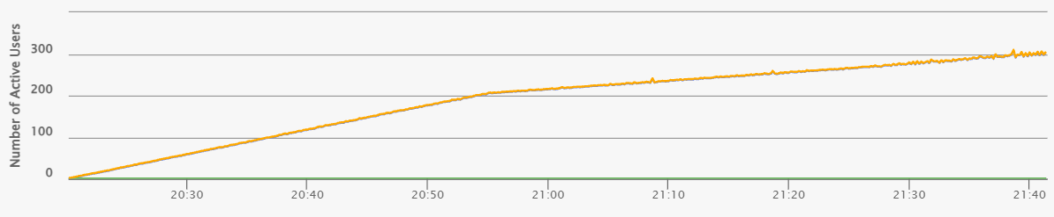
Figure 3.1 – Capacity Test Active Virtual Users (VUs) Ramp-up Profile
Main load parameters:
- Peak Virtual Users: ~320 active threads (virtual users) in both tests (JMeter 318, Gatling 304).
- Total Duration: ~94 minutes for JMeter (01:26 – 03:00) and ~81 minutes for Gatling (18:20 – 19:41), with times as shown on the dashboards.
- Ramp-up Period: the entire test. Users were added gradually in two stages with no constant-load plateau: stage 1 (first ~35 minutes) from 1 to ~200 users, and stage 2 (remaining time) from ~200 to ~320 users.
- Ramp-up Rate: about 1 new user every 10 seconds (~5.7 users per minute) in stage 1, slowing to about 1 new user every 30 seconds (~2 users per minute) in stage 2.
Neither test reached the planned 400 virtual users or the 30-minute peak hold. Both ended earlier, which is consistent with the early-stop criterion in the test configuration.

4. Test Start and End Date/Time
Table 4.1 – Capacity Test Start/End Dates and Execution Duration
Tool | Start | End | Duration
JMeter | 2026-11-01 01:26:13 | 2026-11-01 03:00:37 | ~94 min
Gatling | 2026-10-31 20:20:13 | 2026-10-31 21:41:29 | ~81 min

5. Link to the Test HTML Reports
The detailed results of both tests are stored in the html-reports directory, with one sub-folder per tool.
- JMeter (CapacityTest_20261101-0126):
  - report/index.html: the generated HTML dashboard.
  - results.jtl: the raw results file.
  - jmeter.log and console.log: the execution logs.
- Gatling (CapacityTest_Gatling_20261031182012656):
  - index.html: the generated HTML report, with per-request and per-group pages.
  - simulation.log: the raw results file.

6. Detailed results

6.1 Capacity Test Analysis: Throughput, Response Time and Errors vs. Load
In this test the number of active virtual users (yellow line) increases steadily. The charts show throughput (green, req/s), pct90 response time (blue) and errors (red). The dashed vertical markers show the saturation and instability points.

6.1.1 Expected behavior
Throughput: grows with the load, then levels off at a plateau when the system reaches its limit.
pct90 response time: stays stable or rises slightly under normal load. A sharp rise signals saturation.
Errors: stay at zero in normal operation. Their sustained growth signals overload.

6.1.2 Key observations: JMeter
Saturation (~01:54, ≈ 160 VU): throughput reaches ~43 req/s and stays flat. pct90 rises from ~0.2 s to ~3 s within ~5 minutes. There are no errors.
Degradation (01:54 – 02:41): throughput stays flat at ~43 req/s while pct90 grows steadily to ~9 s. Errors are limited to isolated spikes and rise slowly from ~02:30.
Instability (~02:41, ≈ 270 VU): pct90 stays at ~9–10 s, capped by the 10 s timeout. Throughput oscillates and drops to ~39 req/s, and errors reach up to ~16 err/s.
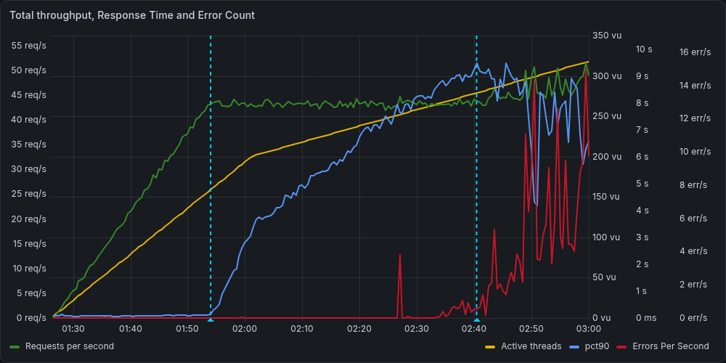
Figure 6.1 – JMeter: Total Throughput (RPS), pct90 Response Time, and Error Count vs. Load

6.1.3 Key observations: Gatling
- Saturation (~20:48, ≈ 160–170 VU): throughput reaches ~44 req/s and stays flat. pct90 rises from ~0.2 s to ~3 s within ~7 minutes. There are no errors.
- Degradation (20:48 – 21:26): throughput stays flat at ~43 req/s while pct90 grows steadily to ~8.5 s. Errors are sporadic.
- Instability (~21:26, ≈ 270 VU): pct90 stays at ~8–9 s with sharp swings. Throughput shows dips near the end, and errors reach up to ~160 per interval.
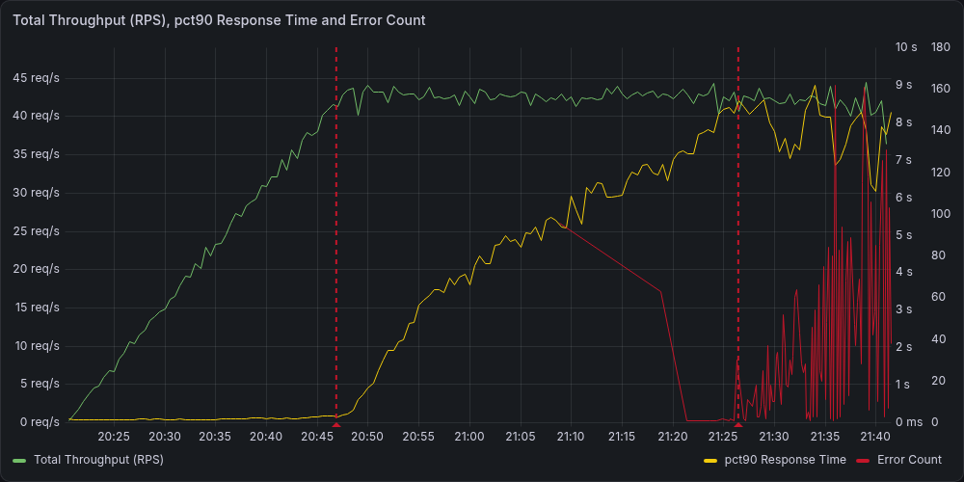
Figure 6.2 – Gatling: Total Throughput (RPS), pct90 Response Time, and Error Count

6.1.4 Conclusion
- In both tools, throughput stops growing at ≈ 160 VU (~43–44 req/s). This is the saturation point. Above it, extra users only increase latency.
- Between ≈ 160 and ≈ 270 VU the system stays functional but degraded: pct90 climbs from ~3 s to ~9 s with almost no errors.
- Above ≈ 270 VU errors become systematic and the system is unstable.
- The working capacity limit is therefore ≈ 160 VU, or ~43 req/s.
- The charts show where the limit is, but not which component causes it. That needs backend and database metrics.

6.2 Response time per transaction
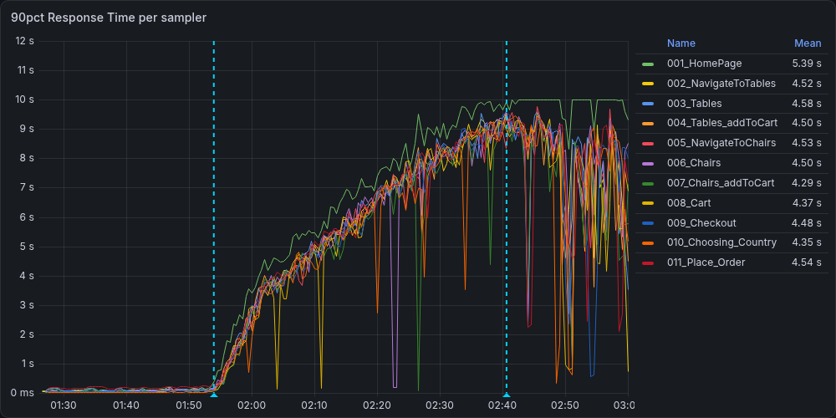
Figure 6.3 – JMeter: 90th Percentile Response Time per Sampler
Up to the saturation point (around 01:54), all transactions execute quickly and consistently, with 90th-percentile response times below roughly 0.2 s. Once this threshold is crossed, response times for all transactions grow almost in lockstep, reaching about 9–10 s by 02:40. The curves then flatten at around 10 s, which suggests a client- or server-side timeout, and become erratic as errors start to dominate.
The HomePage transaction is the slowest throughout (mean pct90 of 5.39 s versus 4.3–4.5 s for the rest) and also accounts for the largest share of errors. SubmitOrder does not stand out as a distinct bottleneck: its mean pct90 (4.54 s) is in line with the other transactions. The near-identical degradation across all steps, including lightweight ones such as Cart and LoadStateDropdown, points to a shared backend constraint, most likely exhausted worker or database connection pools, rather than to the business logic of a single operation.
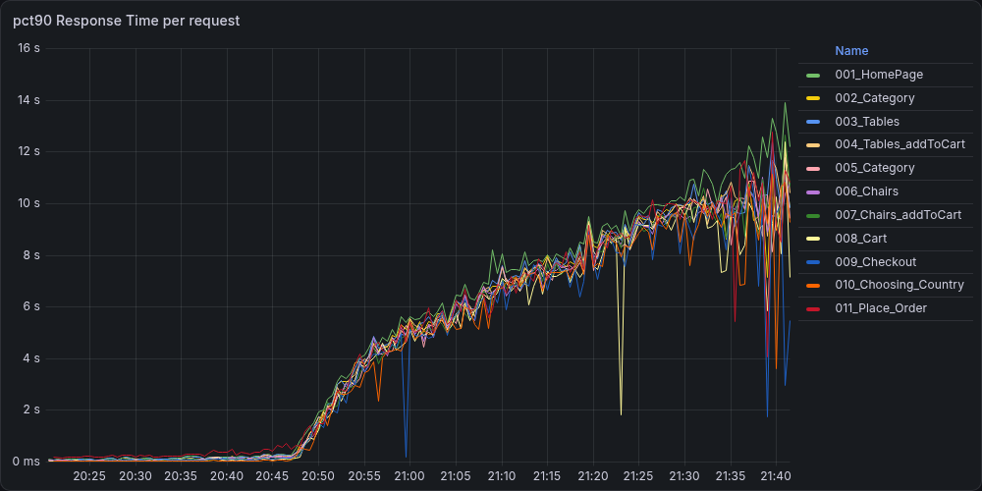
Figure 6.4 – Gatling: 90th Percentile Response Time per Request
The Gatling run shows the same pattern. Up to the saturation point (about 20:48) the 90th-percentile response time of every request stays below roughly 0.2 s. After that it grows almost in lockstep for all requests, reaching 8–10 s by 21:20–21:30 and 12–14 s at the very end of the test. HomePage is again the slowest request and ends 1–2 s above the others, while SubmitOrder (011_Place_Order) is not distinguishable from the rest. The sharp short-lived drops of individual curves, mostly after 21:35, coincide with the period of the highest error counts and are caused by quickly failing requests, not by recovery.

6.3 Errors per transaction
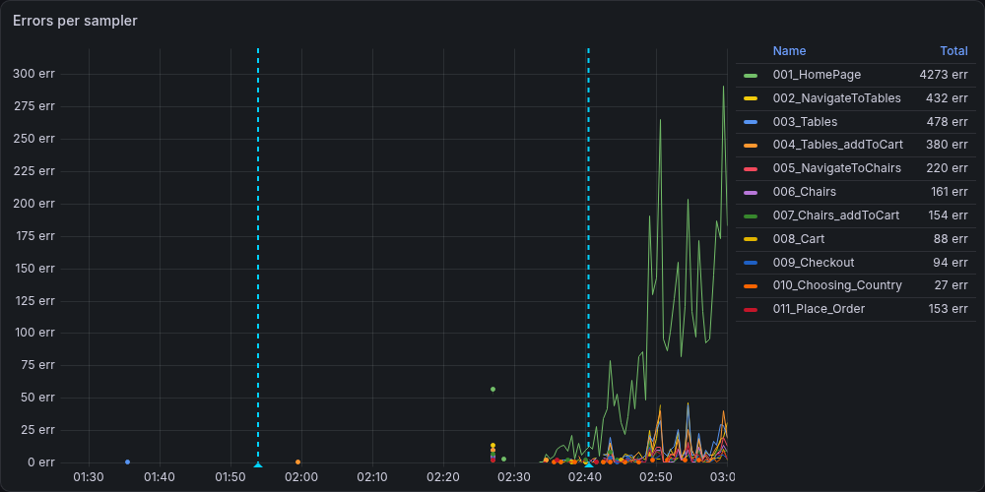
Figure 6.5 – JMeter: Error Count Timeline per Sampler
Errors are negligible until about 02:35, start growing around 02:40, and escalate sharply until the test is stopped at about 03:00, when load approaches 300 virtual users. This is well after response times began to degrade at about 01:54 (around 200 virtual users), so the error cascade is a consequence of saturation rather than its onset.
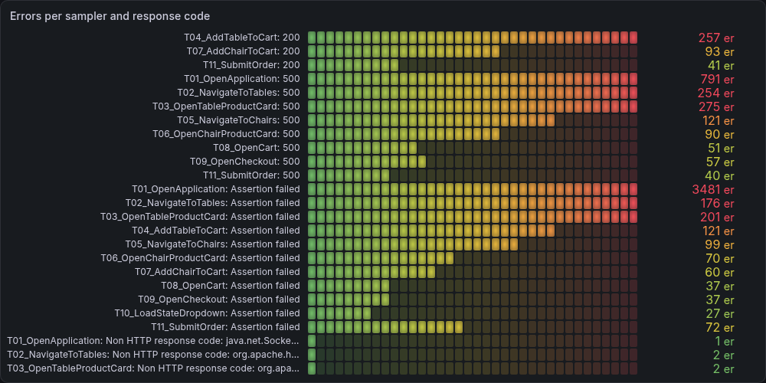
Figure 6.6 – JMeter: Detailed Errors by Sampler and HTTP Response Code / Assertion
Errors are concentrated on the entry point of the scenario. HomePage accounts for 4,273 of roughly 5,600 failed samples (about 76%), whereas SubmitOrder accounts for only 153.
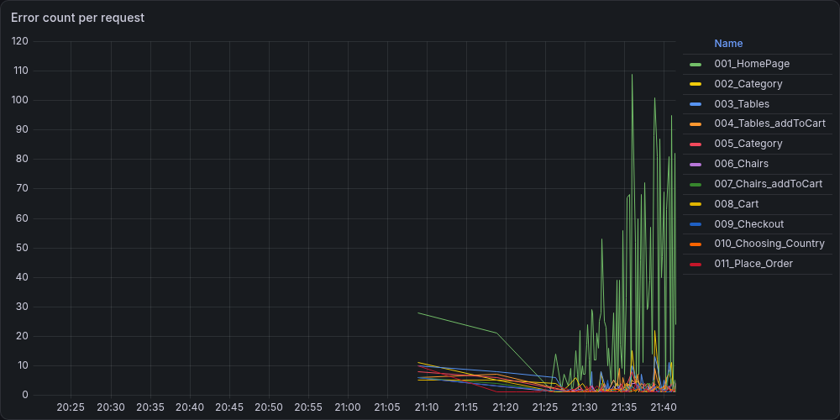
Figure 6.7 – Gatling: Error Count Timeline per Request
The Gatling run shows the same pattern. Response times start to grow at the saturation point (about 20:48), whereas errors remain sporadic for roughly another 40 minutes and begin to grow systematically only from about 21:26, at around 270 virtual users. They then escalate until the end of the test at about 21:41, reaching up to roughly 160 errors per interval, while throughput drops from about 43 to 36–40 req/s. In both tools, therefore, the system first slows down without failing and only later starts to fail, which is typical for queue-driven saturation: requests wait longer and longer until they exceed the timeout and are rejected or returned as errors.
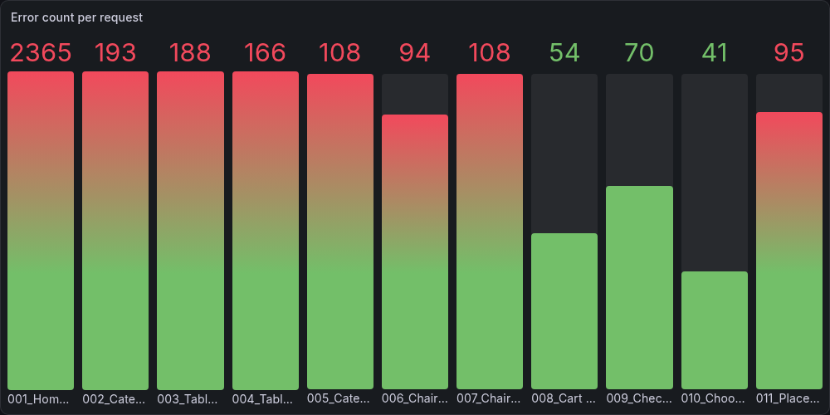
Figure 6.8 – Gatling: Total Error Distribution per Request
In Gatling run errors are again concentrated on the first step of the scenario: HomePage accounts for 2,365 of about 3,480 errors shown on the dashboard (about 68%), whereas Place_Order accounts for 95.
Taken together, the data is consistent with the application layer running out of capacity: requests queue until response times approach the 10 s limit, after which they start to fail with HTTP 500 responses and failed assertions. The likely cause is exhaustion of PHP-FPM workers or database connections, which would hit HomePage first because it opens every scenario iteration.
A practical consequence is that the capacity limit should be read from the onset of response-time growth (≈160 virtual users, about 43 req/s) and not from the onset of errors (≈270 virtual users). The error threshold alone would overstate the capacity of the system by roughly 70%, because for more than half of the test the system was already degraded while still returning mostly successful responses.

6.4 Technical causes of instability and their correlation with metrics

6.4.1 CPU utilization
In the JMeter run, CPU utilization grows together with the number of virtual users until the saturation point and then stays in a stable band. Per-core load rises from about 10% at the start to 20–60% at 01:54, and remains within this band for the next 45 minutes although the number of virtual users keeps growing. This is the same behavior as for throughput: CPU follows the request rate, which is capped, and not the number of users. Only in the instability zone (after about 02:45) are short peaks of 80–85% visible on individual cores, which coincide with the growth of errors. Mean per-core utilization ranges from 26% (cores 10 and 11) to 46% (cores 2 and 3), with maximum values of 69–80%. No core is pinned at 100%.
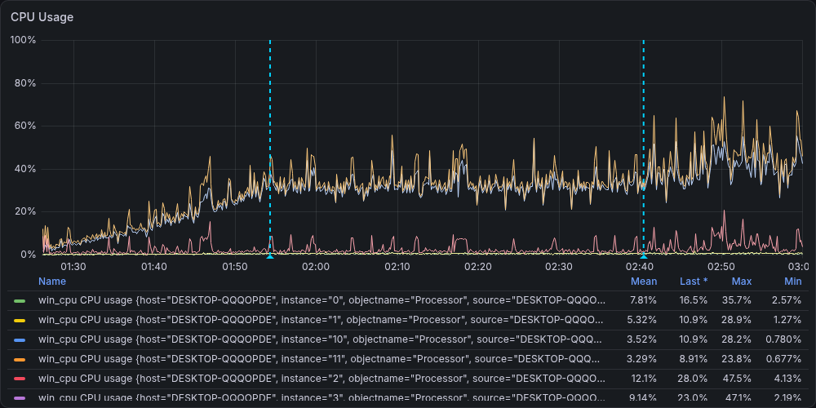
Figure 6.9 – JMeter: System Host CPU Utilization Breakdown
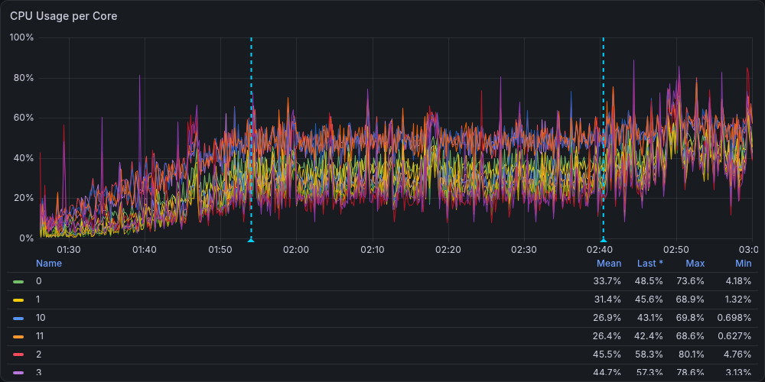
Figure 6.10 – JMeter: System Host CPU Usage per Core
The Gatling run shows the same picture. Total processor time rises during ramp-up and stabilizes at about 35–45% from the saturation point, with mean 32.1% and peaks up to 59.1%. Interrupt and DPC time stay below 1.7%, so there is no sign of driver, network-card or disk interrupt pressure. Most of the load is privileged (kernel) time, with a mean of 29.5%, whereas user time is only 2.6%. A likely explanation is that the application runs in Docker containers, where the CPU time of the virtualized environment is accounted as privileged time by the host; this means the host metrics cannot show how much CPU the PHP and database processes themselves consume. The per-core view is uneven: cores 2 and 3 average about 44% (maximum 75%), while cores 10 and 11 average about 27%. The values of cores form similar pairs (0/1, 2/3, 10/11), which is consistent with hyper-threading siblings.
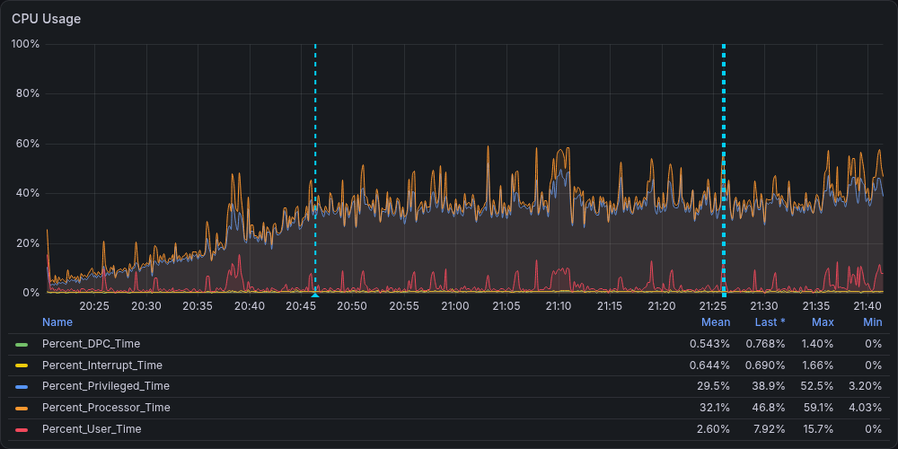
Figure 6.11 – Gatling: System Host CPU Utilization Breakdown
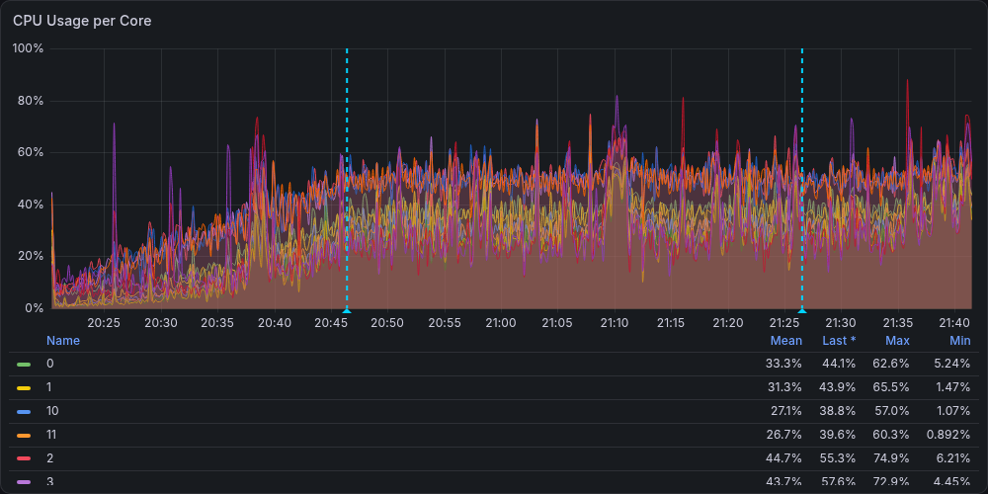
Figure 6.12 – Gatling: System Host CPU Usage per Core
In both tests the host CPU stays far below saturation: the mean total is about one third of the capacity and the peaks are below 60%, while individual cores peak at 62–85% only for short periods. CPU utilization stops growing at the same moment as throughput, and it does not show a step at the instability point. Therefore the throughput ceiling of ≈43 req/s is not caused by exhaustion of host CPU, which points to a limit inside the application stack (for example, the number of PHP workers or database connections).

6.4.2 Memory utilization and paging
Memory consumption on the host grows during both tests instead of staying constant.
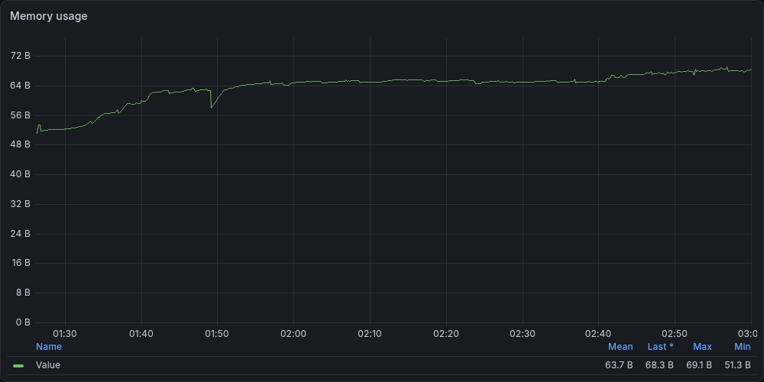
Figure 6.13 – JMeter: System Host Memory Utilization Trend
In the JMeter run it rises from about 52 GB at the start to about 63 GB at 01:48, i.e. during the ramp-up, drops briefly by about 5 GB at 01:49, shortly before the saturation point (01:54), and then stays at about 65 GB until the instability point. After about 02:40 it grows again and reaches 69.1 GB (mean 63.7 GB).
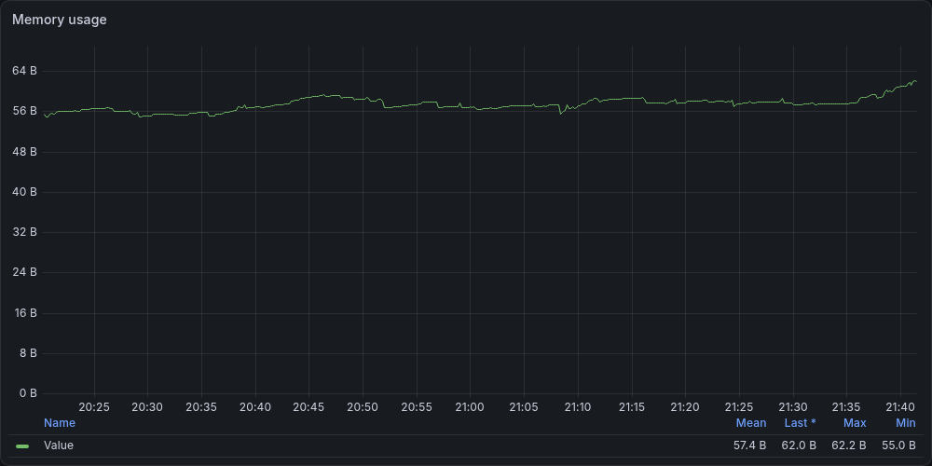
Figure 6.14 – Gatling: System Host Memory Utilization Trend
In the Gatling run the growth is smaller: from 55 GB to about 59 GB at the saturation point (20:48), about 57–58 GB afterwards, and a rise to 62.2 GB after 21:35, in the instability zone (mean 57.4 GB). The load generator explains only a part of this growth, since the JMeter process uses about 3 GB, so the rest comes from other processes on the shared host, most probably the application and database containers.
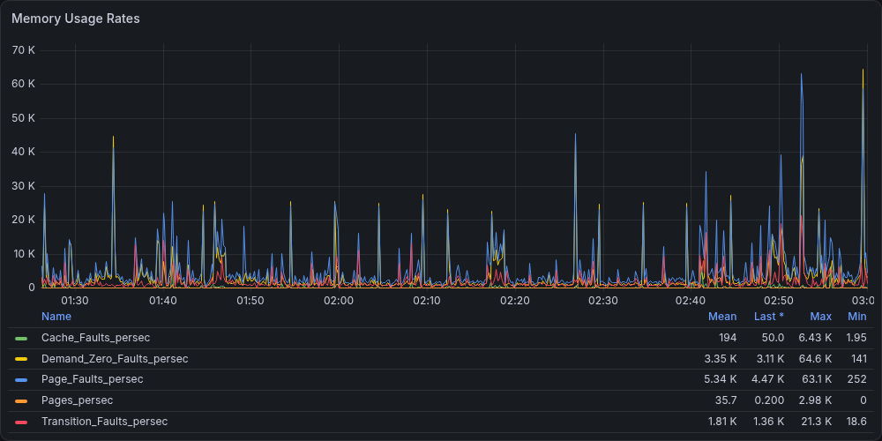
Figure 6.15 – JMeter: System Host Memory Paging & Fault Rates
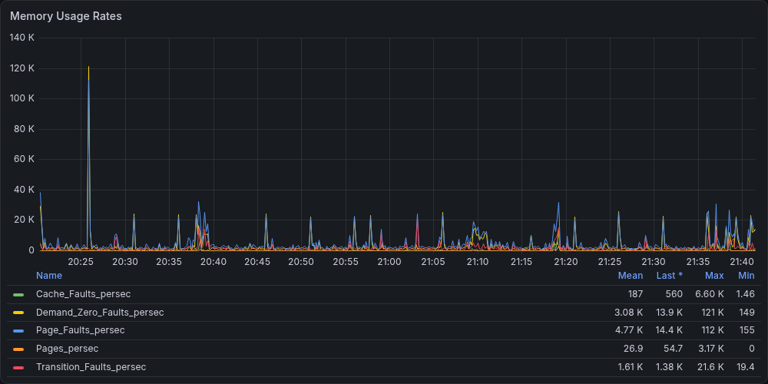
Figure 6.16 – Gatling: System Host Memory Paging & Fault Rates
The paging metrics do not indicate memory exhaustion. The mean Pages/sec is 27–36 and reaches about 3,000 only in short peaks, so the system did not swap intensively. The mean page-fault rate is 4.8–5.3 thousand per second, of which most are demand-zero faults, i.e. allocation of new pages. In both runs short peaks of about 20–25 thousand per second repeat roughly every five minutes regardless of the load, which suggests a periodic background activity. In the instability zone the peaks become larger and more frequent (up to about 64 thousand per second in JMeter after 02:50). This coincides with the growth of memory and errors and is consistent with the creation of new worker processes or connections under overload, but this cannot be confirmed with host-level metrics alone.
So, memory is not the cause of the throughput limit: there is no paging, and the saturation point is not accompanied by any step in memory usage.

6.4.3 Disk and network
Free disk space stayed constant during both runs, which means that logs and result files did not consume a significant amount of storage. Disk activity was dominated by write operations, which is expected, since the tools continuously write test results and logs, while read activity was negligible. Overall disk utilization remained low and was characterized by short, isolated peaks. The disk queue was empty most of the time and showed only brief, occasional spikes. This behavior indicates that there was no I/O saturation. The disk profiles of the two runs were similar, so the choice of the load testing tool did not noticeably change disk consumption.
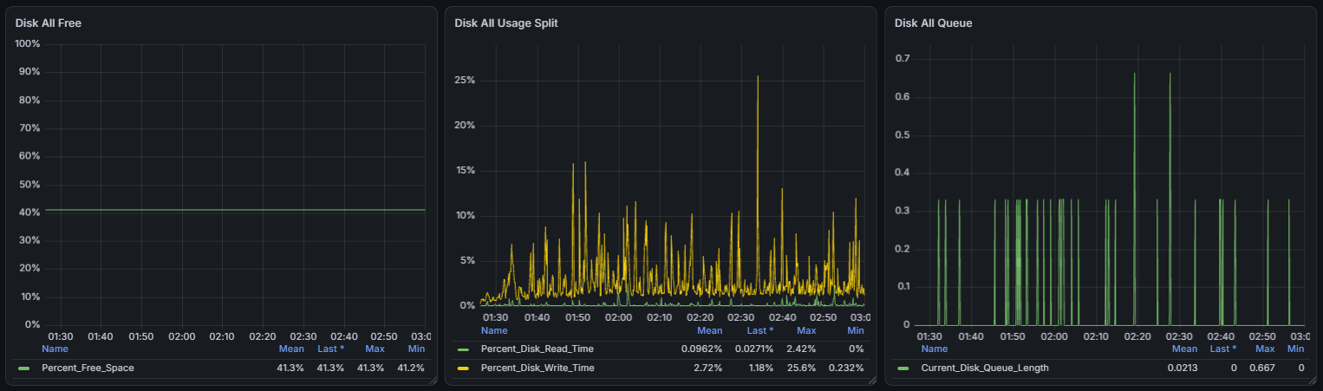Figure 6.15 – JMeter: system disk activity
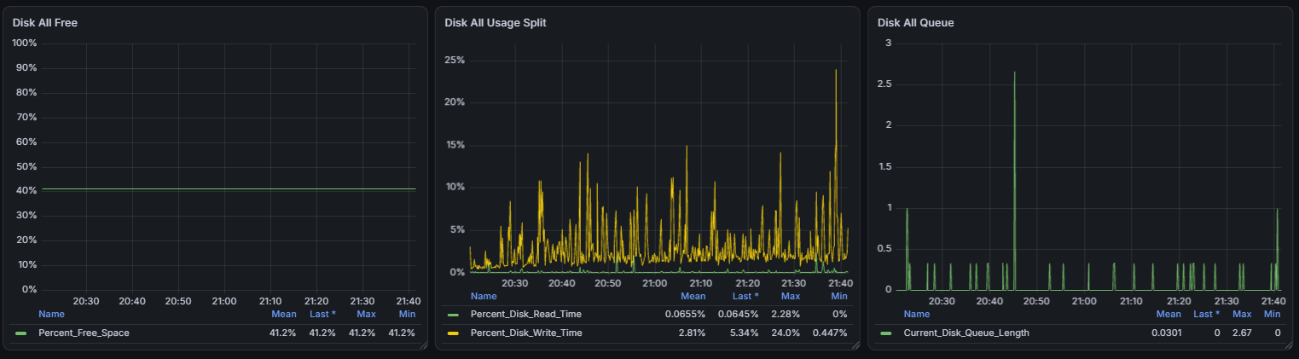Figure 6.16 – Gatling: system disk activity
Network throughput and packet rates followed the request/response flow produced by the test, with occasional bursts during the most intensive phases of the load. Network usage remained well below the capacity of the interface, so the network adapter did not become a bottleneck on the load generator side.
In summary, disk and network resources of the load generator were sufficient throughout both runs and did not influence the test results.

6.4.4 Load generator health
In the JMeter run, heap usage grew during the initial ramp-up and then settled into a regular sawtooth pattern of gradual allocation followed by garbage collection. The heap stayed within a moderate range, well below its configured maximum, and showed no continuous upward trend, which rules out a memory leak. GC events were frequent and regular, and their cumulative time increased only slightly as the load was sustained. Individual collections remained short, with no long pauses that could affect the measured response times.
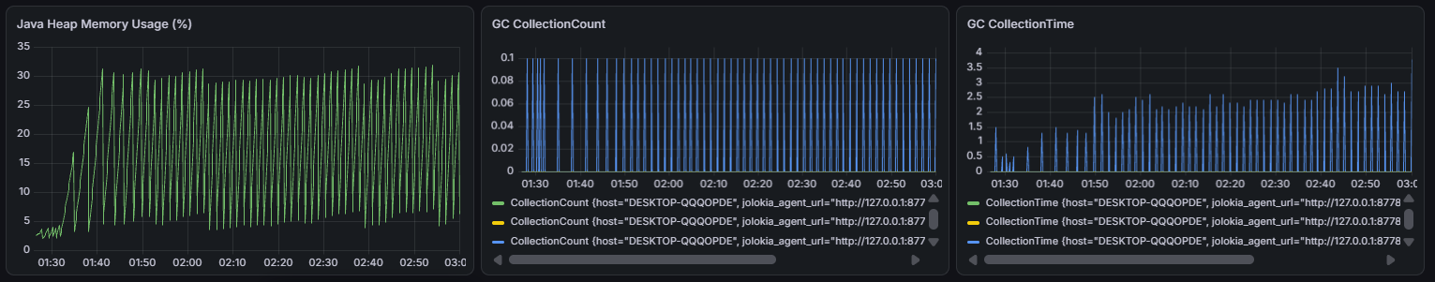Figure 6.17 – JMeter: JVM heap usage and garbage collection
In the Gatling run, heap usage was considerably lower and more stable. Memory grew slowly and gradually between collections, and GC events were rare and brief. This is consistent with the lightweight, asynchronous architecture of Gatling, which requires fewer resources to generate a comparable load.
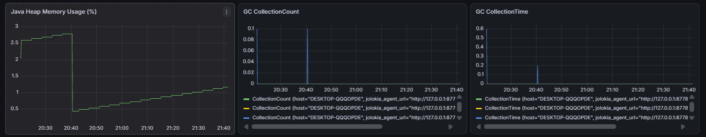Figure 6.18 – Gatling: JVM heap usage and garbage collection
In both cases the JVM operated stably, with no signs of memory pressure or GC-related delays. The load generators therefore had enough resources to create the required load.

6.4.5 Conclusion
In both tests the throughput stopped growing at about 160 virtual users (≈43 req/s) while the host resources were far from exhausted: mean CPU utilization was about one third of the capacity with no core pinned at 100%, memory showed no intensive paging, and disk and network usage were low and did not change at the saturation or instability points. CPU and memory followed the request rate, not the number of users, and changed noticeably only in the instability zone, where they are a consequence of overload rather than its cause. Together with the identical degradation of all transactions and the prevalence of HTTP 500 responses and failed assertions over connection-level errors, this indicates that the limit lies inside the application stack, most probably in the number of PHP workers or database connections, which makes requests queue until they exceed the timeout.

7. Capacity test conclusion
The capacity test showed consistent results in both tools. The system handles up to about 160 virtual users (≈43 req/s) without degradation; this is its working capacity limit. At this point throughput stops growing, and every additional user only lengthens the queue: the 90th-percentile response time grows from about 0.2 s to 9–10 s over the next 45 minutes, while errors remain sporadic. Above about 270 virtual users the system becomes unstable: errors (mainly failed assertions and HTTP 500 responses) grow systematically, response times hit the timeout limit, and throughput starts to fluctuate and fall. The degradation affects all transactions almost equally, and the home page is the main weak point, with the slowest responses and about two thirds of all errors, whereas the order submission step is not a distinct bottleneck. Host CPU, memory, disk and network were not exhausted in either test, and the load generators were not limiting, so the limit lies inside the application stack, most probably in the PHP worker or database connection pools.

Response time test

1. Purpose of the test
- Verify system behavior under a stable, constant load.
- Measure response times of key user transactions (browse and checkout flow) under a fixed load profile.
- Establish a performance baseline for future comparisons, and cross-validate the results obtained with two independent load tools (JMeter and Gatling).

2. Summary of Results
The goal of the response time test was achieved. The system sustained a stable load of approximately 125 virtual users (about 35.6-35.7 requests per second) for the whole 30-minute test, processing more than 64,000 requests with 0% errors. Response times remained consistent throughout the run, with no degradation, growth trend, or throughput drops: the median response time was 71-74 ms and the 90th percentile stayed around 100-125 ms. The slowest transaction was Place Order, with a median of about 216 ms and a 90th percentile of about 284 ms in JMeter. This is still acceptable for a checkout operation and was stable over time. Results from both tools (JMeter and Gatling) were consistent with each other, which confirms that the measurements are reliable. The obtained values can be used as a performance baseline for future test runs.

2.1 Response Time Analysis and Resource Utilization

2.1.1 Response Time Analysis
Table 2.1 – Response Time Test Performance Summary & Baseline Metrics
Metric | Value
Load profile | 125 virtual users, constant load, 30 min
Throughput (requests per sec / per min) | ~35.6 RPS / ~2,135 per min (JMeter 35.6, Gatling 35.7)
Total requests | ~64,050 user transactions (JMeter: 64,048; Gatling dashboard: 64,060)
Response time | Median: ~70-73 ms; 90th percentile: ~125-130 ms; 95th percentile: ~143-181 ms; 99th percentile: ~258-261 ms
90th percentile response time per transaction | ~38 ms up to ~284 ms (JMeter), ~35 ms up to ~430 ms (Gatling, per-interval peak values)
95th percentile per transaction | ~44 ms up to ~314 ms (JMeter); up to ~1 s (Gatling, per-interval peak values)
Percentage of requests in response time ranges | ~79.4% of requests: < 100 ms  ~17.0% of requests: 100–200 ms  ~3.5% of requests: 200–500 ms  ~0.1% of requests: 500 ms – 1 s  <0.01% of requests (4 total): 1–2 s  0% of requests: > 2 s
Behavior | Throughput and response times were stable throughout the test. No degradation trend. Only minor isolated spikes in the 90th percentile (up to ~150 ms overall; ~380–430 ms for individual transactions), with no impact on stability.
Errors | 0% errors
Web app CPU usage | Host CPU (system-wide) ~29% on average in both runs (JMeter run 29.4%, Gatling run 28.8%), per-core peaks up to ~60%
Web app memory usage | Host free memory stayed stable at ~10–13 GB (JMeter run ~10.1 GB, Gatling run ~12.8 GB)
List of APIs with 95th percentile response time > 2 sec | None (slowest: Place Order, 95th ~314 ms)
Slowest transaction | 011_Place_Order: median ~216 ms, 90th ~283 ms, 95th ~314 ms
011_Place_Order: median ~216 ms, 90th ~283 ms, 95th ~314 ms | JMeter: avg ~9%, max ~20%. Gatling: avg ~4%, max ~12%
Load generator memory (java.exe) | JMeter: ~2.2–3.0 GB working set. Gatling: ~0.3–0.5 GB
A response time test was performed to measure the response time of user transactions under ~80% of the capacity load. The test was executed with 128 virtual users, which is 80% of the capacity point determined by the capacity test (160 virtual users). Under this load, the throughput was ~35.6 requests per second (~2,135 per minute).
The median response time of all transactions was ~70-73 ms. The 90th percentile was ~130 ms, the 95th percentile was ~143-181 ms (Gatling-JMeter), and the 99th percentile was ~258-261 ms. The 95th percentile response time of individual transactions varied from ~44 ms to ~314 ms. The slowest transaction was T11_SubmitOrder (median ~216 ms, 95th percentile ~314 ms), which is expected for an operation that creates an order. The fastest were the lightweight AJAX operations (T10_LoadStateDropdown: median ~27 ms; T04_AddTableToCart and T07_AddChairToCart: median ~36 ms).
The deviation of the 95th percentile from the median was ~60-165% for most transactions (about 2.5 times overall), which means that 50% of requests are roughly 2.5 times faster than the 95th percentile response time. In absolute terms, however, the deviation is small (tens of milliseconds), and the response times were consistent from the start to the end of the test: the median response time per minute stayed within 69-88 ms, and no degradation trend or inconsistent spikes were observed. The results obtained with two tools (JMeter and Gatling) are consistent with each other.
Almost all transactions (~99.9%) had a response time of less than 500 ms (~79% of transactions: below 100 ms, ~17%: 100-200 ms, ~3.5%: 200-500 ms).
Table 2.2 – Per-Transaction Response Time Breakdown
Transaction | Count | Throughput (req/s) | Median (ms) | 90th pct (ms) | 95th pct (ms) | Max (ms)
T01_OpenApplication | 9566 | 5.31 | 96 | 149 | 171 | 1296
T02_NavigateToTables | 9566 | 5.31 | 75 | 108 | 134 | 1397
 | 9566 | 5.32 | 82 | 130 | 151 | 904
  T03_OpenTableProductCard
T04_AddTableToCart | 9556 | 5.31 | 36 | 73 | 96 | 843
T05_NavigateToChairs | 4779 | 2.66 | 74 | 107 | 127 | 1022
T06_OpenChairProductCard | 4779 | 2.66 | 72 | 102 | 117 | 864
T07_AddChairToCart | 4779 | 2.65 | 36 | 74 | 95 | 751
T08_OpenCart | 2867 | 1.59 | 54 | 79 | 92 | 687
T09_OpenCheckout | 2867 | 1.59 | 58 | 85 | 98 | 754
T10_LoadStateDropdown | 2867 | 1.59 | 27 | 39 | 45 | 743
T11_SubmitOrder | 2867 | 1.59 | 194 | 283 | 297 | 1985
Total | 64050 | ~35.6 | 72 | 130 | 192 | 1985
The results of the two tools are consistent. The system handled ~35.6 requests per second (~64,050 transactions in 30 minutes) with 0% errors. The average response time was ~78 ms, the median ~72 ms, the 90th percentile ~130 ms and the 95th percentile ~162 ms. Throughput was distributed according to the user scenario: ~5.3 req/s for the first four transactions (browsing and adding a table), ~2.7 req/s for the chair branch, and ~1.6 req/s for the checkout steps. The slowest transaction was Submit Order (average ~206 ms, 95th percentile ~297 ms); the fastest were the lightweight AJAX operations Choose Country, Add to Cart (median 27-36 ms). The 95th percentile of every transaction stayed below 300 ms, and the maximum values (up to ~2 s) were isolated outliers. The measured values can be used as a performance baseline.

2.1.2 Resource Utilization
Main Resource Bottleneck: No resource bottleneck was observed at the tested load. Server CPU, RAM, disk and network stayed far below saturation. Response times were flat and throughput matched the target (~35.6 req/s) throughout the test, with 0% errors, which indicates that no request queues built up. The slowest transaction was Submit Order, which is expected for an operation that creates an order; at this load level it had no negative effect on overall stability.
CPU Behavior per Cores: The load was evenly distributed across all logical cores. Total CPU usage of the host machine was ~29% on average (with peaks up to ~60% on individual cores) and was stable throughout the test. Average usage per core was ~22-30% (peaks up to ~46-60%), and no single core reached 100% saturation or showed signs of core pinning. Total CPU usage was ~29% in both runs (JMeter and Gatling) and stayed stable.
RAM (Random Access Memory): Memory utilization of the host machine was ~61-67% of the total 32 GB (27.8 GB usable by the operating system) and was stable throughout the test (the Memory Usage panel shows a smooth trend around ~61-67% of total memory, with free memory of ~10-13 GB). There are no signs of memory leaks or excessive garbage collection pauses.
Disk Subsystem (I/O and Queues): Disk activity was minimal: average disk time was ~0.1-0.2% for reads and ~1.4-3.2% for writes, with brief write spikes of ~11-12%. The average disk queue length was ~0.02-0.03 (peak 0.33), and free disk space remained constant at ~41%. The disk subsystem was not a limiting factor.
Network Usage (Bytes and SentBytes): Network traffic was stable and correlated directly with the request throughput: ~533 MiB received and ~65 MiB sent in total over 30 minutes (~0.3 MiB/s received on average). Interface-level traffic stayed far below the NIC limits, with no packet drops or saturation.
Agent CPU Usage: The CPU consumption of the load generator was stable and low: ~9% on average (peaks up to ~20%) for JMeter and ~4% (peaks up to ~12%) for Gatling. The monitoring agent (Telegraf) added only short, negligible spikes. There were no signs of thread starvation or client-side performance degradation.
Load Generator State (java.exe): The java.exe process running the load generators (JMeter / Gatling) was in a healthy, stable state. Thread count (147 for JMeter, 10 for Gatling), handle count and private memory remained constant, and heap usage followed a normal garbage collection pattern without growth. This confirms that the measured response times reflect the behavior of the system under test and not of the load generators.

2.2 Service Level Agreements (SLA) Definition
Table 2.3 – Service Level Agreements (SLA) Compliance & Fulfillment
Metric | Target SLA | Test Data | Fulfillment Status
Request Success Rate | ≥99.0% successful requests | 100% successful requests | Сompleted
Error Rate | <1.0% | 0% errors | Completed
Response Time (Lightweight operations) | < 0.5 s | All lightweight transactions remained well below 0.5 s at the percentile level used for evaluation. Individual transaction p95 values ranged from approximately 45 ms to 171 ms, excluding Submit Order | Completed
Response Time (Submit Order) | < 2 s | Submit Order median: approximately 194–216 ms;  p90: approximately 283 ms;  p95: approximately 297–314 ms. JMeter maximum was approximately 1.99 s | Completed
Resource Consumption (CPU) | $<80\%$ average load across all cores |  | Сompleted
  Host CPU approximately 29%
  on average in both runs (JMeter
  ~29.4%, Gatling ~28.8%);
  individual-core peaks
  approximately 46–60%,
  without sustained saturation
Resource Consumption (RAM) | $<80\%$ average load | Approximately 10.1 GB free during the JMeter run and 12.8 GB free during the Gatling run. Memory remained stable throughout the test | Completed
User Satisfaction (APDEX) | ≥0.80 (Good / Acceptable) | The overall index is 0.999 (Excellent) | Сompleted
The performance testing results confirm that the system operates with high stability at ~80% of its measured capacity, showing 0% errors, zero throughput degradation, and zero resource bottlenecks. The aggregate APDEX index reached 0.999 (with individual transactions scoring up to 0.9995), which firmly classifies the application performance as "Excellent". Approximately 99.9% of all executed requests completed well within the target 0.5-second "Satisfied" APDEX threshold.
Lightweight operations—such as drop-down menu loading and add-to-cart actions—achieved minimal latencies (median 27–36 ms) and a perfect 1.000 APDEX score. Even the heaviest transaction, SubmitOrder, maintained a strong APDEX score of 0.998–0.999, with its median response time (194–216 ms) and overall distribution staying significantly below the 2.0-second SLA limit.

2.3 Conclusions and Areas of Concern
Conclusions: The response time test was successfully passed (status: PASS). The system remained stable while handling ~125–128 virtual users and ~35.6–35.7 requests per second over a 30-minute period, with zero errors and significant resource headroom. Approximately 79% of transactions were completed in under 100 ms (median: 71–73 ms), and the infrastructure did not reach saturation. These results will serve as a baseline profile for future releases.
Areas of Focus: The `Submit Order` transaction remains the slowest (with p95 reaching 297–314 ms), requiring dedicated monitoring due to its potential load on the database. Additionally, attention should be paid to occasional response time outliers (reaching 1–2 seconds), the spread between percentiles, and the risk of gradual memory leaks—which a 30-minute test cannot detect.

3. Load Profile
The evaluation utilized a steady, closed workload designed to isolate normal operating behavior rather than push the system to its absolute limits. Unlike the capacity test—which progressively scaled user load until performance degradation occurred—this test maintained a constant load at approximately 80% of the predetermined system saturation point. Based on prior capacity test results, where saturation was established at roughly 160 virtual users, the target load for this evaluation was fixed at 128 concurrent virtual users.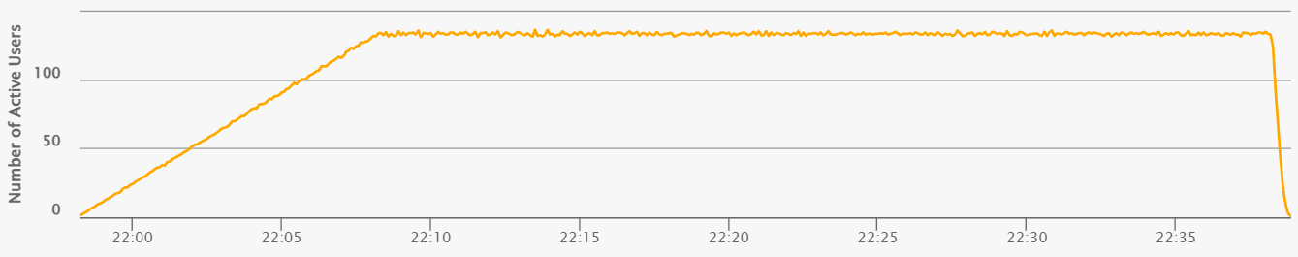
Figure 3.1 – Steady-State Load Profile
Maintaining this consistent load profile facilitated the early detection of latency drift, periodic performance spikes, and underlying resource accumulation. The steady workload was sustained for a duration of 30 minutes to ensure sufficient observation time under stable operating conditions.
To ensure a rigorous and fair analysis, identical business scenarios and transaction distributions were executed using both JMeter and Gatling. This methodological consistency enabled a direct performance comparison between the two load-generation tools under equivalent workload conditions.

4. Test Start and End Date/Time
Table 4.1 – Capacity Test Start/End Dates and Execution Duration
Tool | Start | End | Duration
JMeter | 2026-11-02 12:36 | 2026-11-02 13:06 | 30 min
Gatling | 2026-11-02 20:08 | 2026-11-02 20:38 | 30 min

5. Link to the Test HTML Reports
The detailed results of both tests are stored in the html-reports directory, with one sub-folder per tool.
- JMeter (ResponseTimeTest_20261102-1426):
  - report/index.html: the generated HTML dashboard.
  - results.jtl: the raw results file.
  - jmeter.log and console.log: the execution logs.
- Gatling (ResponseTimeTest_Gatling_20261102195813566):
  - index.html: the generated HTML report, with per-request and per-group pages.
  - simulation.log: the raw results file.

6. Detailed results
In the JMeter run the number of active threads is held flat at about 128, throughput oscillates between roughly 34 and 37 req/s, and pct90 stays in a narrow band of about 90–130 ms. The Gatling run shows the same picture: throughput stays close to 35–36 req/s, and pct90 fluctuates around a baseline of about 100 ms with a maximum of about 151 ms. The very first and last Gatling throughput points are partial intervals at the window edges and do not reflect application behaviour.
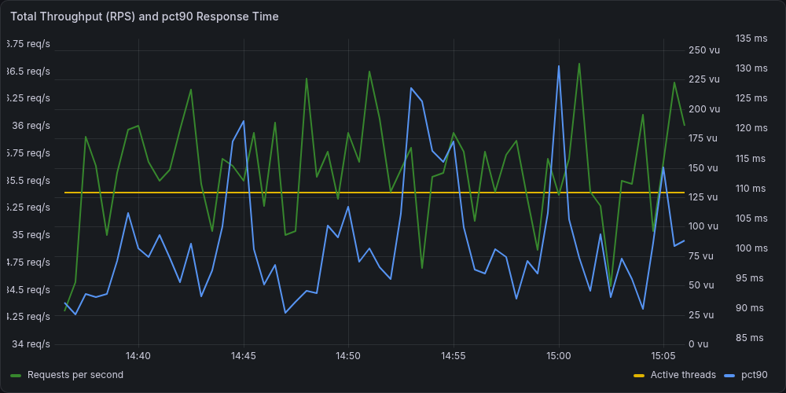
Figure 6.1 – JMeter: total throughput (RPS), pct90 response time and active threads
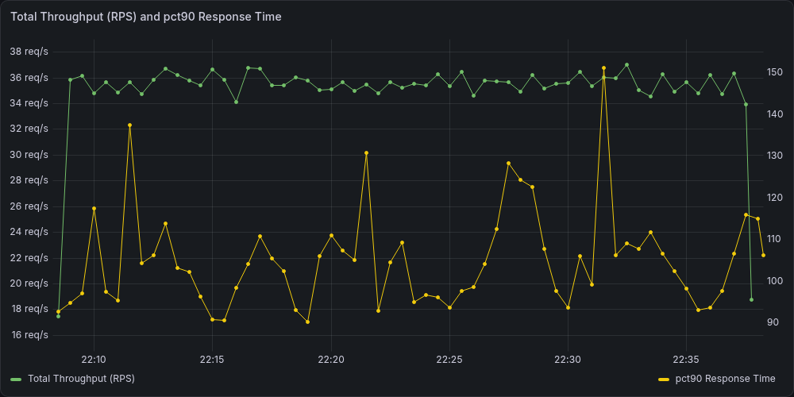
Figure 6.2 – Gatling: total throughput (RPS) and pct90 response time
In both runs there is no upward drift of pct90 and no decline of throughput over the hold period. The short peaks recover within one or two sampling intervals, which indicates transient fluctuations and not progressive degradation.
No performance-related errors were observed during the steady response-time test. JMeter recorded zero failed top-level transactions, and the attached Grafana/Gatling dashboards also show a 0% error rate for the analyzed steady run. Therefore, there is no evidence of timeout accumulation, HTTP 5xx growth or assertion failures at this operating point.

6.1 Response Time Behavior
The distribution is strongly concentrated below 200 ms: about 79% of transactions completed in under 100 ms and about 17% between 100 and 200 ms. Only a small fraction exceeded 500 ms, four transactions reached the 1–2 s range, and none exceeded 2 s.
Table 6.1 – Distribution of top-level transaction response times
Range | Count | Share
< 100 ms | 50384 | 78.668%
100–200 ms | 11323 | 17.679%
200–500 ms | 2273 | 3.549%
500 ms–1 s | 62 | 0.097%
1–2 s | 4 | 0.006%
> 2 s | 0 | 0.000%
The relative ordering of the steps is the same in both tools, which confirms that heavy operations behave predictably while lightweight interactions remain fast:
- Heavy operation: placing the order (011_Place_Order) is the slowest business step. Its pct90 stays mostly in the 200–350 ms range in both tools, with a mean of 284 ms in JMeter.
- Middle group: page-level steps (home page, tables, category navigation and product pages) typically cluster around 100–150 ms.
- Lightweight actions: cart, checkout page and add-to-cart operations complete in roughly 75–85 ms, while choosing the country is the fastest step at about 40 ms (mean pct90 of 39 ms).
In the top-level transaction data the slowest transaction is SubmitOrder: median 194 ms, 90th percentile 283 ms, 95th percentile 297 ms and maximum 1,985 ms. OpenApplication (the home page) is the next one that deserves attention: its 95th percentile is only 171 ms, but its maximum exceeds one second. The fastest transaction is LoadStateDropdown with a median of 27 ms and a 95th percentile of 45 ms.

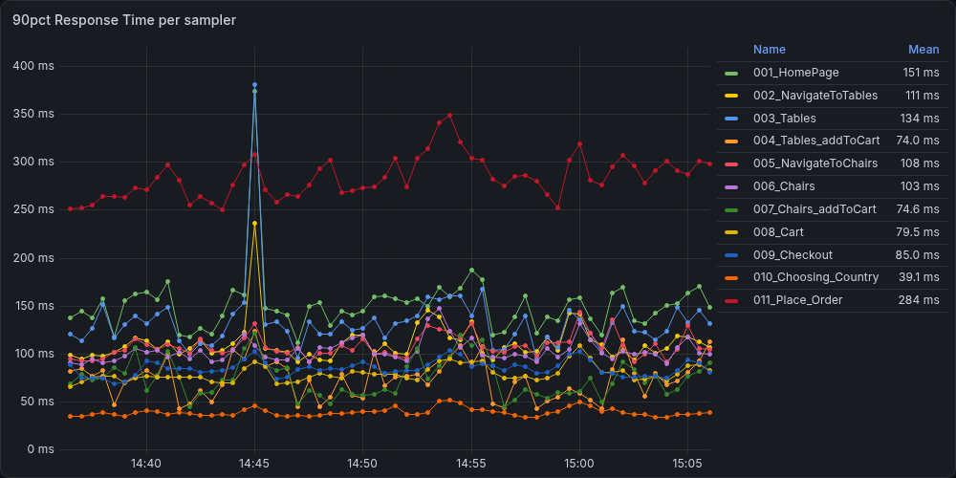
Figure 6.3 – JMeter: pct90 response time per sampler
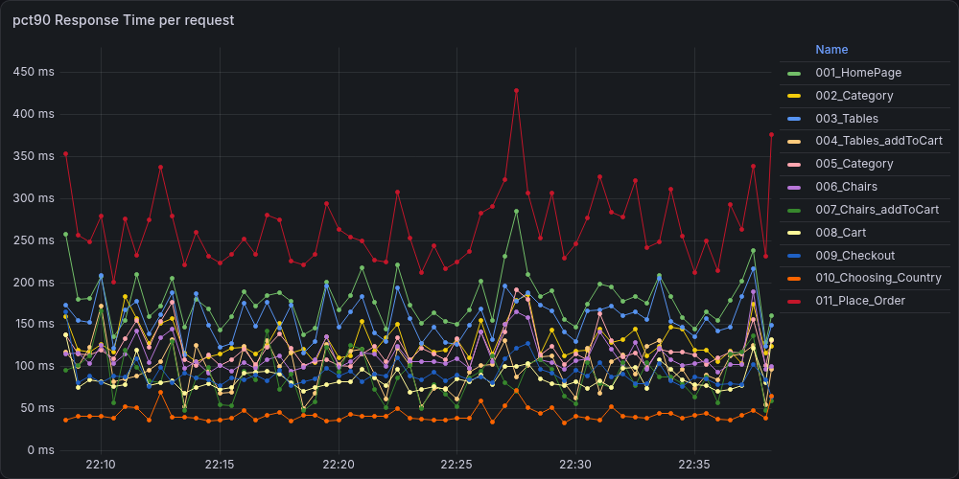
Figure 6.4 – Gatling: pct90 response time per request
Outliers are isolated, transient spikes are occasionally visible across both tool runs (e.g., brief bumps near the 375–430 ms range). Because these rare spikes typically affect multiple steps simultaneously and resolve quickly within the next sampling interval, they indicate temporary, shared environmental fluctuations rather than isolated endpoint degradation.
Overall, even the slowest individual transactions maintained stability under the tested load, ensuring no adverse impact on overall system throughput.

6.2 Throughput Behavior
The throughput of every step is flat and falls into three bands: about 5.3 req/s for the steps executed in every iteration, about 2.65 req/s for the chair steps and about 1.6 req/s for the steps from the cart to the order. These bands correspond exactly to the 100%, 50% and 30% shares of the scenario, so the workload mix was reproduced correctly and held stable by both tools. The sum of the per-step rates (about 35.6 req/s) matches the total throughput.
This behavior differs materially from the capacity test after saturation, where throughput reached a ceiling and response time grew as requests accumulated in queues. In the response-time test no such queue-building pattern is visible: no step lost throughput, and pct90 did not grow while the load stayed constant.
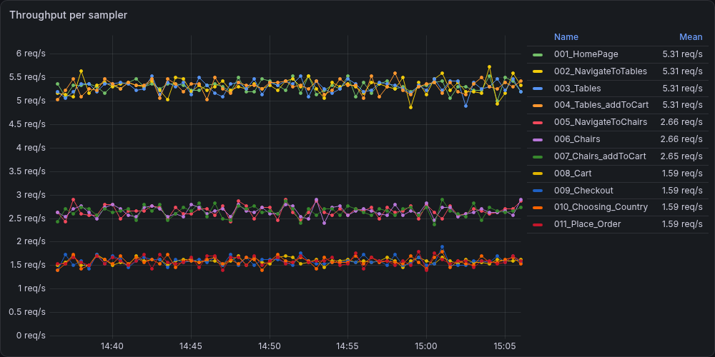
Figure 6.5 – JMeter: throughput per sampler
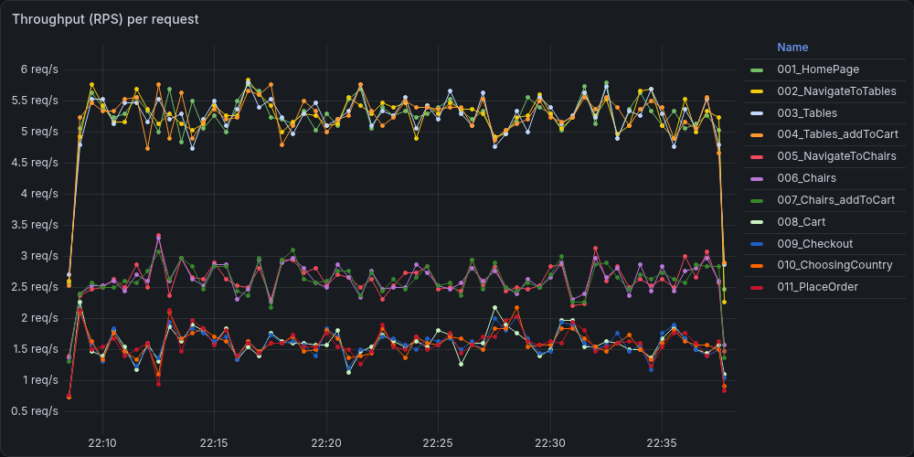
Figure 6.6 – Gatling: throughput (RPS) per request
Outliers are isolated, transient spikes are visible in both runs. These spikes are rare, typically affect several steps at the same moment and resolve within the next sampling interval. This points to a temporary, shared environmental fluctuation and not to degradation of a single endpoint.
As illustrated in the per-sampler/per-request charts, all transaction lines run parallel and flat throughout the entire 30-minute duration without throttling, sudden drops, or divergence. This uniform behavior confirms that the workload generators injected traffic evenly and that the system under test processed requests predictably under a constant load profile.

6.3 Conclusions
The response-time test shows that the application is stable under a constant load of 128 virtual users. Both load-generation tools lead to the same conclusions:
- Stable response time. pct90 stays around 90–130 ms in JMeter and around 100 ms in Gatling, with no drift over the 30-minute hold. About 96% of transactions completed in under 200 ms and none exceeded 2 s.
- Stable throughput. Total throughput stays at 35–36 req/s. No queue-building pattern is observed, unlike in the capacity test after saturation.
- Expected step hierarchy. Placing the order is the slowest step (mean pct90 of 284 ms) and the main candidate for future optimisation, followed by page-level steps at 100–150 ms; lightweight steps take about 40–85 ms. The ordering is identical in both tools.
- No errors. Zero failed transactions and a 0% error rate in both runs.
- Rare outliers. Isolated spikes (four transactions of about 64,000 above 1 s) are short, shared across steps and self-recovering. They are worth monitoring in future runs, but they do not affect the overall result.
Consequently, the selected operating point is suitable as a baseline for normal-load performance comparisons.

6.4 System Resource Utilization
The load generator, the application under test and the monitoring stack run on the same machine. The host-level metrics therefore describe the combined load of the whole test environment and cannot be attributed to the application alone.

6.4.1 CPU utilization
Host CPU utilization was moderate and stable in both runs. Average total utilization was about 29%, with short peaks of roughly 50–60% and a minimum of about 10–15%, so more than two thirds of the CPU capacity remained available throughout the test. There is no upward trend over the hold period, which is consistent with the constant load profile.
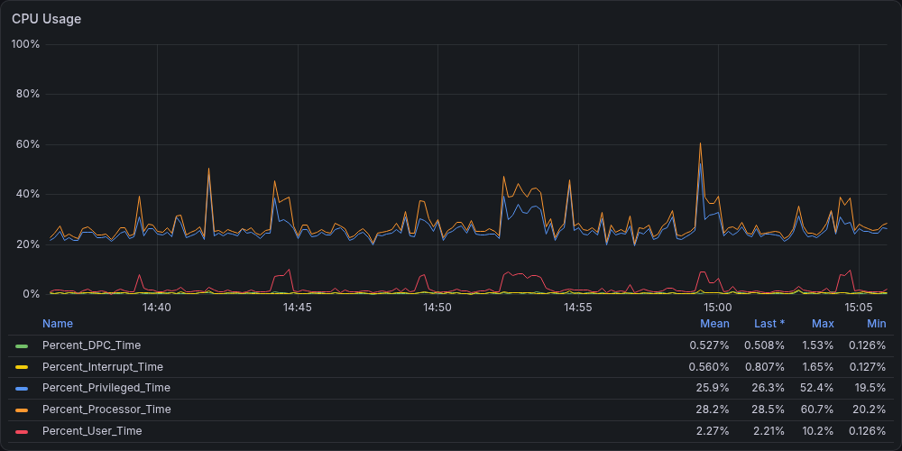
Figure 6.7 – JMeter: System Host CPU Utilization Breakdown
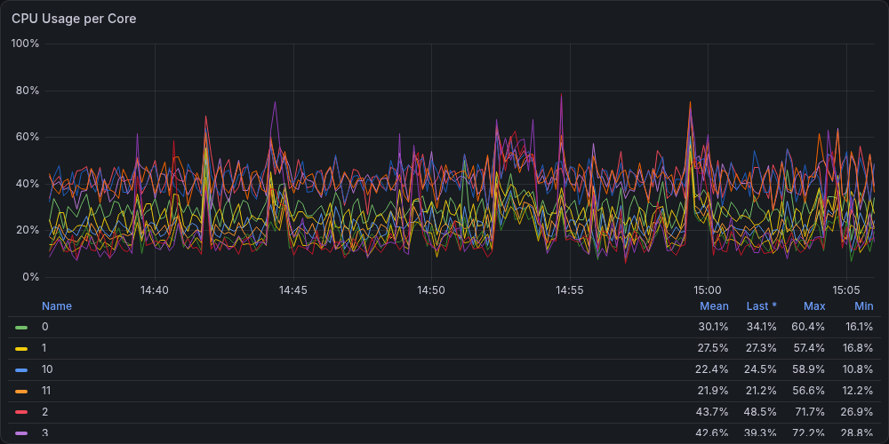
Figure 6.8 – JMeter: System Host CPU Usage per Core
The load was distributed evenly across the logical cores: per-core averages stayed in a narrow band of roughly 20–30%, and no core was saturated for a sustained period. Context-switch and system-call rates were also stable and showed no sustained growth. The CPU profiles of the JMeter and Gatling runs are practically identical, so differences between the tools in the response-time results are unlikely to be caused by a different CPU load on the host.
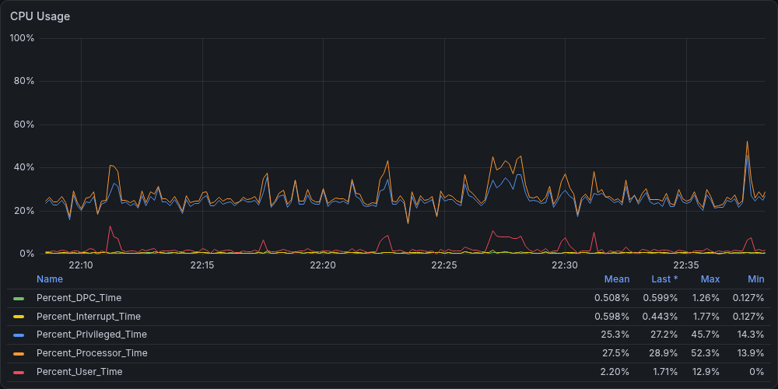
Figure 6.9 – Gatling: System Host CPU Utilization Breakdown
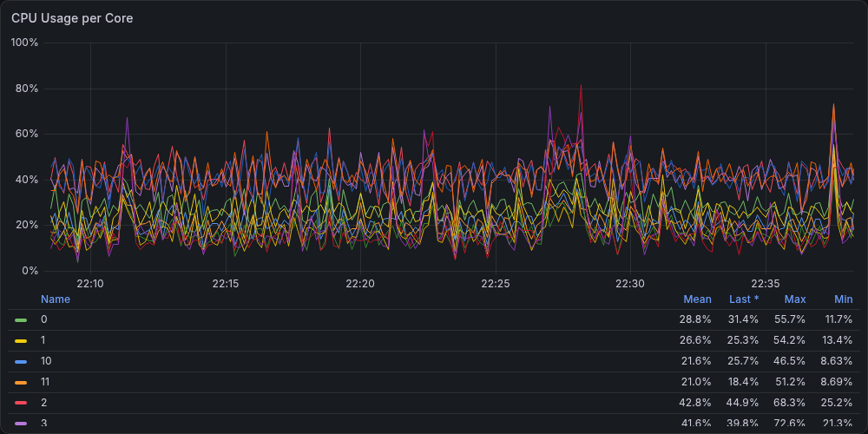
Figure 6.10 – Gatling: System Host CPU Usage per Core

6.4.2 Memory utilization and paging
Memory utilization was stable in both runs. Used physical memory stayed within a narrow range of roughly 57–68% of the total, with about 10–13 GB remaining free and no growth trend that would indicate a memory leak or accumulating memory pressure. The slightly higher usage in the JMeter run is consistent with the larger memory footprint of the JMeter process (see the load generator analysis below).
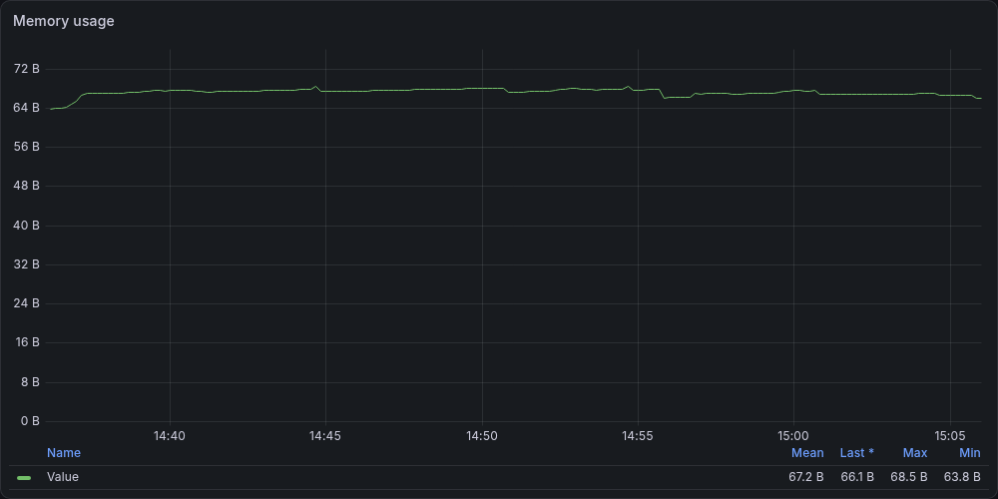
Figure 6.11 – JMeter: System Host Memory Utilization Trend
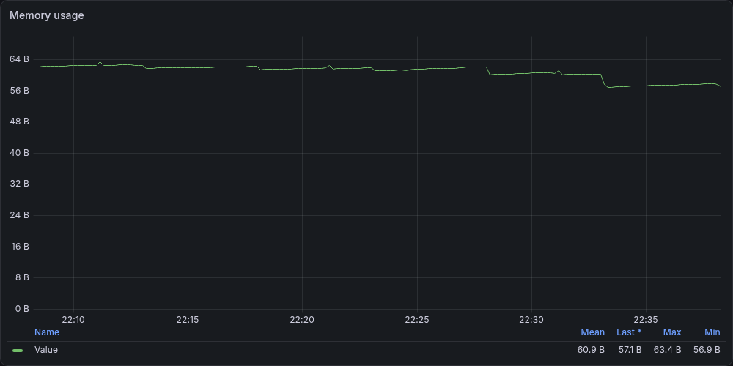
Figure 6.12 – Gatling: System Host Memory Utilization Trend
The paging and fault counters show a low-to-moderate, steady rate of page, cache and demand-zero faults with only short isolated peaks in both runs. These counters mainly reflect normal allocation and file-cache activity of a busy Windows host and include soft faults, so they do not by themselves indicate paging to disk. No sustained paging activity was observed, and free memory did not shrink during the tests.
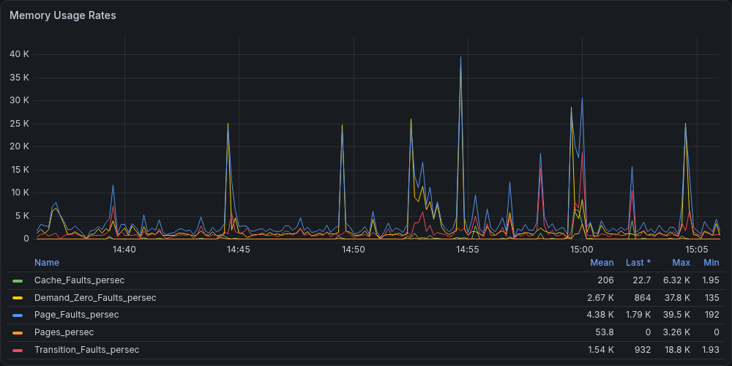
Figure 6.13 – JMeter: System Host Memory Paging & Fault Rates
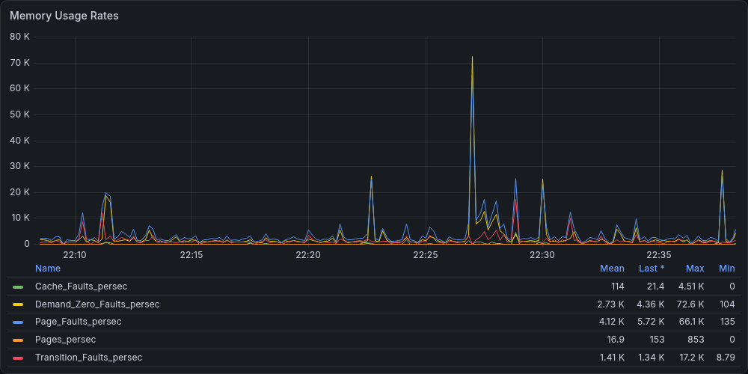
Figure 6.14 – Gatling: System Host Memory Paging & Fault Rates

6.4.3 Disk and network
Disk activity was low in both runs. The average disk queue length was close to zero with only short isolated peaks, the disk was busy only a few percent of the time on average (writes dominated, reads were negligible), write throughput stayed below 1 MB/s, and the free disk space remained constant at about 41%.
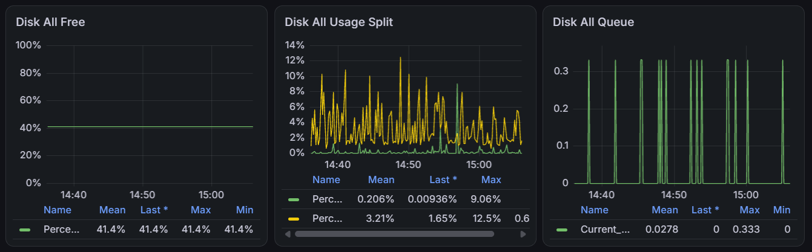
Figure 6.15 – JMeter: System Disk activity
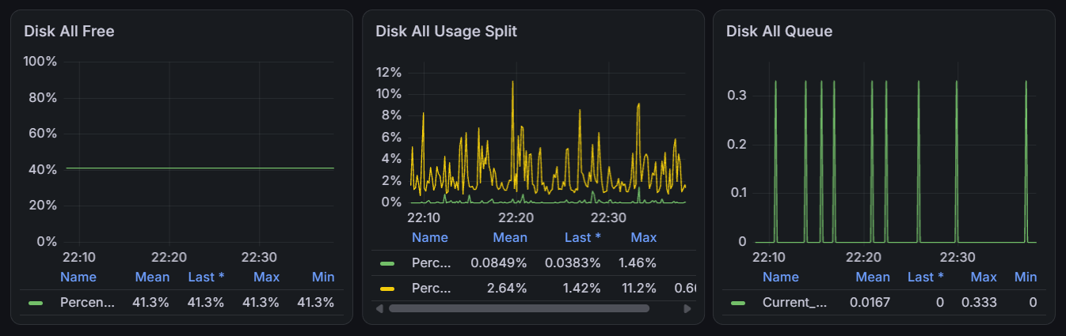
Figure 6.16 – Gatling: System Disk activity
Traffic on the physical network interfaces was negligible: on average a few kilobytes and a few packets per second, with rare isolated peaks, far below the interface capacity. This is expected, because the traffic between the load generator and the application stays on the local loopback interface and does not pass through the physical network adapters. Consequently, neither the disk nor the network subsystem showed any sign of saturation, and neither can be considered a limiting factor for the response time.

6.4.4 Load generator health
Both load generators run as Java processes on the same host, so their own resource consumption was monitored to make sure that the generators did not become a bottleneck and distort the measurements.
Both generators were lightweight. Their processor usage remained a small fraction of the host CPU (on average roughly 9% for JMeter and 4% for Gatling according to the process counter), and the handle and thread counts were constant, with no memory growth. JMeter occupied a considerably larger memory footprint (a working set of about 3 GB) than Gatling (about 0.5 GB) and used roughly 150 threads for 128 virtual users, whereas Gatling, which relies on an asynchronous model, needed only about ten threads.
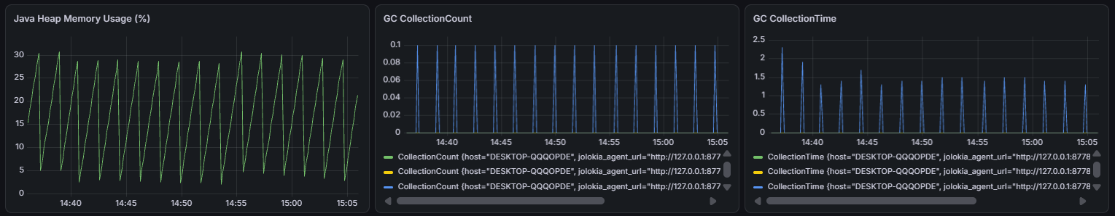
Figure 6.17 – JMeter: JVM heap usage
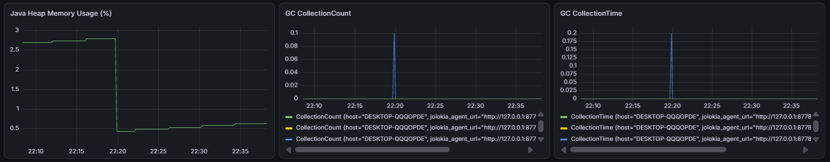
Figure 6.18 – JMeter: JVM heap usage
JVM heap usage followed a regular sawtooth pattern in the JMeter run and stayed well below the configured maximum (about 30% at most), with short and regular garbage-collection pauses. In the Gatling run heap usage was minimal (a few percent) and garbage-collection activity was almost absent. Therefore, the load generators had sufficient resources, and the measured response times are not affected by generator-side limitations such as CPU starvation or garbage-collection pauses.

6.4.5 Conclusion
The analysis of system resources shows that the host operated far from saturation in both runs. CPU utilization averaged about 29% with ample headroom, memory usage was stable with no sign of leaks or paging pressure, and disk and network activity was negligible. The load generators themselves were lightweight and stable, and the resource profiles of the JMeter and Gatling runs are very close to each other.
It can therefore be concluded that no host resource limited the application during the response-time test, and the response times and throughput reported above reflect the behavior of the application under the selected load. The same resource profile can serve as a reference for comparison with later test runs. The main limitation is that the load generator, the application and the monitoring stack share one host, so the metrics represent the combined load of the test environment.

Response time test conclusion
The response-time performance evaluation successfully demonstrated that the system operates with high stability under a sustained, constant load of 128 concurrent virtual users (~35.6–35.7 requests per second) over a 30-minute test window. Cross-validation using two independent load-generation tools (JMeter and Gatling) yielded highly consistent results, confirming the reliability of the collected metrics.
Key findings and performance highlights include:
- High Reliability & Zero Errors: The application processed over 64,000 user transactions with a 0% error rate and no evidence of timeout accumulation, HTTP 5xx responses, or assertion failures.
- Exceptional Response Times: Approximately 96% of all transactions completed in under 200 ms (with ~79% finishing below 100 ms). The overall median response time remained low at 70–74 ms, and the 90th percentile stayed within 100–130 ms.
- Predictable Transaction Hierarchy: Lightweight AJAX operations performed the fastest (medians of 27–36 ms), standard page-level browsing clustered around 100–150 ms, and the write-heavy order placement (SubmitOrder) represented the slowest step (mean p90 of 284 ms).
- Ample Infrastructure Headroom: Host CPU utilization averaged a stable ~29%, available memory remained steady with ~10–13 GB free, and disk/network subsystems showed minimal activity without signs of saturation.
So, the system passed all defined SLAs with an outstanding aggregate APDEX score of 0.999 ("Excellent"). The performance metrics established in this test provide a reliable baseline for normal-load comparisons in future releases.

Stability time test

1. Purpose of the test
• Verify system stability under a steady load over an extended period.
• Check for memory leaks or bottlenecks that may become apparent after the system has been running for a long time.

2. Summary of Results
The stability test successfully fulfilled its purpose by confirming system resilience under prolonged continuous load without crashes, throughput loss, or SLA breaches. However, the extended execution revealed late-stage latency degradation—particularly in complex transactions—accompanied by slight increases in errors and disk write activity, indicating potential application- or database-level bottlenecks that warrant investigation before higher-scale testing.

2.1 Metrics Analysis and Resource Utilization

2.1.1 Metrics Analysis
Table 2.1 – Stability Test Performance Summary & Baseline Metrics
Metric | Value
Load profile | 125 virtual users, constant load, 240 min (after a 10 min ramp-up)
Throughput (requests per sec / per min) | 35.5 RPS (≈2,128 RPM)
Total requests | JMeter: 510,734 (steady state, 240 min)  Gatling: 512,024 (steady state, 240 min)
Response time | JMeter: median 75 ms, mean 89 ms, 99th pct 370 ms, max 5,045 ms  Gatling: median 72 ms, mean 83 ms, 99th pct 315 ms, max 3,421 ms
90th percentile response time per transaction | JMeter: 147 ms overall; from 46 ms (T10_LoadStateDropdown) to 335 ms (T11_SubmitOrder)  Gatling: 141 ms overall
95th percentile per transaction | JMeter: 192 ms overall; from 61 ms (T10) to 473 ms (T11)  Gatling: 165 ms overall (report), 176 ms (Grafana); from 53 ms (010_Choosing_Country) to 497 ms (011_Place_Order)
Percentage of requests in response time ranges | JMeter: 75.2% < 100 ms; 20.4% 100–200 ms; 4.0% 200–500 ms; 0.5% > 500 ms (0.01% > 2 s)  Gatling: 99.89% < 800 ms; 0.08% 800–1,200 ms; 0.03% ≥ 1,200 ms
Behavior | Throughput is stable at ≈35.5 req/s (33.5–37.5 req/s at 1 s resolution) with no decline over 240 min. Response time is stable for the first ≈3 hours (JMeter 30-min average 79 → 88 ms) and then degrades: in the last 30 min the JMeter average is 122 ms (+55% vs the first 30 min), the 95th percentile 343 ms, and the T11_SubmitOrder average 417 ms (+149%). Gatling shows the same pattern: pct90 grows from ≈100 ms to 200–500 ms in the last hours.
Errors | JMeter: 87 of 510,734 (0.017%): 83 × NoHttpResponseException, 2 × SocketException, 2 × HTTP 500; 39 of them in the last hour  Gatling: 0 (0%)
Web app CPU usage | Web app and load generator share one host. Host CPU: 32.0% average during the JMeter run, 30.5% during the Gatling run; per-core peaks up to ≈65%. The java processes account for ≈9.2% (JMeter run) and ≈4.2% (Gatling run) of it.
Web app memory usage | Host RAM in use: average 72.9% (66.1–80.5%) during the JMeter run and 59.9% (57.9–63.4%) during the Gatling run; free memory at the end 7.1 GB and 11.5 GB. Usage crept up from ≈70% to ≈76% during the JMeter run and stayed flat during the Gatling run.
List of APIs with 95th percentile response time > 2 sec | None. Highest 95th percentiles: T11_SubmitOrder 473 ms (JMeter), 011_Place_Order 497 ms (Gatling).
Slowest transaction | T11_SubmitOrder / 011_Place_Order in both tools.  JMeter: median 185 ms, 90th 335 ms, 95th 473 ms, max 5,045 ms  Gatling: median 202 ms, 95th 497 ms, 99th 1,146 ms, max 3,548 ms
Load generator memory (java.exe) | JMeter java.exe: RSS ≈2.8–3.0 GB (one step down from 3.0 to 2.85 GB in the first hour, then flat); heap used 0.5–2.3 GB (5–28% of the ≈8.6 GB maximum) in a regular saw-tooth with regular GC: no leak.  Gatling java.exe: RSS ≈100 MB after warm-up (470 MB at start); heap 0.5% → 3.1% of the maximum.

Table 2.2 – Per-Transaction Response Time Breakdown (JMeter)
Transaction | Count | Throughput (req/s) | Median (ms) | 90th pct (ms) | 95th pct (ms) | Max (ms)
T01_OpenApplication | 76,274 | 5.30 | 99 | 165 | 210 | 2,205
T02_NavigateToTables | 76,268 | 5.30 | 80 | 128 | 166 | 1,819
T03_OpenTableProductCard | 76,250 | 5.30 | 84 | 142 | 181 | 1,977
T04_AddTableToCart | 76,232 | 5.29 | 37 | 73 | 100 | 1,120
T05_NavigateToChairs | 38,111 | 2.65 | 79 | 127 | 164 | 1,925
T06_OpenChairProductCard | 38,101 | 2.65 | 75 | 120 | 157 | 1,835
T07_AddChairToCart | 38,098 | 2.65 | 37 | 72 | 99 | 1,048
T08_OpenCart | 22,857 | 1.59 | 56 | 91 | 119 | 1,201
T09_OpenCheckout | 22,851 | 1.59 | 61 | 99 | 127 | 1,400
T10_LoadStateDropdown | 22,848 | 1.59 | 29 | 46 | 61 | 839
T11_SubmitOrder | 22,844 | 1.59 | 185 | 335 | 473 | 5,045
Total | 510,734 | 35.47 | 75 | 147 | 192 | 5,045

Table 2.2b – Per-Transaction Response Time Breakdown (Gatling)
Transaction | Count | Throughput (req/s) | Median (ms) | 95th pct (ms) | 99th pct (ms) | Max (ms)
001_HomePage | 74,996 | 5.20 | 97 | 196 | 371 | 1,842
002_Category | 74,996 | 5.20 | 77 | 150 | 299 | 1,580
003_Tables | 74,996 | 5.20 | 82 | 170 | 321 | 1,527
004_Tables_addToCart | 74,996 | 5.20 | 36 | 99 | 173 | 859
005_Category | 37,500 | 2.60 | 76 | 148 | 318 | 1,108
006_Chairs | 37,500 | 2.60 | 72 | 140 | 287 | 1,408
007_Chairs_addToCart | 37,500 | 2.60 | 36 | 100 | 171 | 860
008_Cart | 22,504 | 1.56 | 54 | 105 | 212 | 955
009_Checkout | 22,504 | 1.56 | 59 | 112 | 220 | 880
010_Choosing_Country | 22,504 | 1.56 | 28 | 53 | 128 | 538
011_Place_Order | 22,504 | 1.56 | 202 | 497 | 1,146 | 3,548
Total | 22,504 | 36.43 | 72 | 165 | 315 | 3,548
Both JMeter and Gatling results demonstrate consistent behavior during the initial three hours. However, performance degradation is observed in the final 30 minutes, where the average response time increases and the 95th percentile grows.
Across all monitored transactions, the home page navigation and product browsing maintain median response times below 100 ms. The checkout and order placement flows (T11_SubmitOrder / 011_Place_Order) represent the heaviest transactions, recording the highest 95th percentiles (473 ms in JMeter and 497 ms in Gatling) and max response times reaching up to 5,045 ms.
The test showed high stability with minimal errors recorded during the JMeter run (87 errors total, representing 0.017% of 510,734 requests) and zero errors during the Gatling run.

2.1.2 Resource Utilization
Main Resource Bottleneck: No resource saturation was observed during either run: host CPU stayed at ≈31%, RAM below 81%, the disk queue below 0.7 and the network was almost idle. The web application, its database and the load generator run on the same host, so host metrics cannot be split per component. The only degrading factor is the application response time (in particular T11_SubmitOrder / 011_Place_Order) in the last 60–90 minutes; since no host resource grows in step with it, the bottleneck should be looked for inside the application/database (e.g. growth of orders and session data, caching, connection handling).
CPU Behavior per Cores: The load is spread evenly over all logical cores (the legends show cores 0, 1 and 10): on average 26–33% per core during the JMeter run and 23–30% during the Gatling run, with short peaks up to ≈65% on single cores. No core was saturated and no upward trend is visible. Total host CPU: 32.0% (JMeter run) and 30.5% (Gatling run).
RAM (Random Access Memory): Used RAM averaged 72.9% (max 80.5%) during the JMeter run and 59.9% (max 63.4%) during the Gatling run; free memory at the end was 7.1 GB and 11.5 GB. In the JMeter run usage crept up from ≈70% to ≈76–80% over four hours; the java.exe private bytes stayed constant at 4.64 GB, so the growth is not caused by the load generator. In the Gatling run usage was flat. Page-fault rates are periodic (page faults: mean 5.7 K/s, peaks 52 K/s in the JMeter run; mean 4.5 K/s, peaks 39 K/s in the Gatling run) without growth: no sign of memory pressure.
Disk Subsystem (I/O and Queues): Free disk space stayed constant at 41.2%. Disk write time averaged 2.6% (peaks 13.5%) in the JMeter run and 2.9% (peaks 11.8%) in the Gatling run, read time ≈0.1%; the disk queue length averaged 0.02–0.03 (max 0.67 and 0.56). The write-rate indicator shows 1.63 MiB/s (JMeter run) and 1.22 MiB/s (Gatling run) at the end and increases during the last part of both runs, which coincides with the response-time degradation, but stays very low in absolute terms: the disk is not a bottleneck.
Network Usage (Bytes and SentBytes): The test traffic goes through the loopback interface (the application is addressed as http://localhost/), so the physical adapters carry only background traffic: ≈6.5 kB/s on average (peaks 0.6 MB/s) during the JMeter run and ≈3.1 kB/s (peaks 0.14 MB/s) during the Gatling run; the wired adapter is idle. According to the JMeter dashboard the test itself received 16.5 GiB (≈1.2 MiB/s) and sent 483 MiB (≈34 KiB/s) in 240 minutes.
Agent CPU Usage: The Telegraf agent stays at 1–6% most of the time with short periodic spikes (up to ≈14% in the JMeter run and ≈12.5% in the Gatling run) at the collection intervals. The overhead is small and without trend, so it does not distort the results.
Load Generator State (java.exe): JMeter java.exe: CPU ≈6–14% (mean 9.2%), RSS ≈2.8–3.0 GB, 146–147 threads, heap used 0.5–2.3 GB (5–28% of the ≈8.6 GB maximum), regular GC, no growth trend. Gatling java.exe: CPU 0.2–0.5% (single spike 2.1%), RSS ≈100 MB after warm-up, 11 threads, heap 0.5% → 3.1% of the maximum with a single GC event at the start. Both generators have a large reserve, so the load generator was not a bottleneck and the measured response times are not distorted by it.

2.2 Service Level Agreements (SLA) Definition
Table 2.3 – Service Level Agreements (SLA) Compliance & Fulfillment
Metric | Target SLA | Test Data | Fulfillment Status
Request Success Rate | ≥99.0% successful requests | JMeter: 99.98% (87 failed of 510,734)  Gatling: 100% | Completed
Error Rate | <1.0% | JMeter: 0.017%  Gatling: 0% | Completed
Response Time (Lightweight operations) | < 0.5 s | 95th pct ≤ 210 ms (JMeter T01–T10), ≤ 196 ms (Gatling 001–010); 99th pct ≤ 403 ms / ≤ 371 ms | Completed
Response Time (Submit Order) | < 2 s | 95th pct 473 ms (JMeter) / 497 ms (Gatling); 99th pct ≈1.15 s; 64 of 22,844 JMeter orders (0.28%) took > 2 s, max 5.0 s; last 15 min: 95th pct 899 ms | Completed (degrading trend)
CPU usage | $<80\%$ average load across all cores | Host CPU 32.0% (JMeter run) / 30.5% (Gatling run); per-core mean 23–33%, peaks ≈65% | Completed
RAM usage | $<80\%$ average load | Used RAM: average 72.9% (JMeter run, peak 80.5%) / 59.9% (Gatling run, peak 63.4%) | Completed (JMeter peak 80.5%)
User Satisfaction (APDEX) | ≥0.80 (Good / Acceptable) | JMeter: 0.997 - Excellent (T = 500 ms, F = 1.5 s), lowest T11_SubmitOrder 0.975  Gatling: ≈0.999 - Excellent (99.89% of requests < 800 ms, 99.97% < 1.2 s; estimated from the report ranges) | Completed
Based on the provided SLA table and APDEX metrics, all predefined Service Level Agreements were fully met, highlighted by an exceptional User Satisfaction (APDEX) score ranging from 0.997 to ~0.999 overall against the target of ≥ 0.80. Even the heaviest transaction (T11_SubmitOrder) achieved a strong score of 0.975 ($T=500\text{ ms},F=1.5\text{ s}$), demonstrating that despite a minor degrading trend in order placement response times during the final 15 minutes, the user experience remained consistently smooth and highly acceptable. This top-tier satisfaction index is supported by near-perfect request success rates (99.98%–100%), sub-200 ms 95th-percentile response times for lightweight operations, and host resource utilization staying comfortably within operational limits throughout the test runs.

2.3 Conclusions and Areas of Concern
Conclusions:
The system successfully completed the extended test duration under a constant workload without crashes, restarts, or throughput loss, with both tools independently confirming baseline stability.
All predefined SLAs were met, maintaining minimal error rates, high user satisfaction scores, and acceptable response times across lightweight and heavy transactions.
Host resource metrics remained within safe operational bounds, showing no CPU saturation or host-level memory leaks.
Areas of Concern:
Both testing platforms detected late-stage response-time degradation, with higher-percentile latencies rising across all transactional workflows during the final phase of the run.
Transport errors slightly increased toward the end of the test in JMeter, accompanied by gradual RAM growth and increased disk write activity.
Because the application, database, and load generation tools shared a single host, the root cause of the degradation could not be isolated. Detailed per-process monitoring of backend components and a longer endurance run (8–12 hours) are recommended.

3. Load Profile
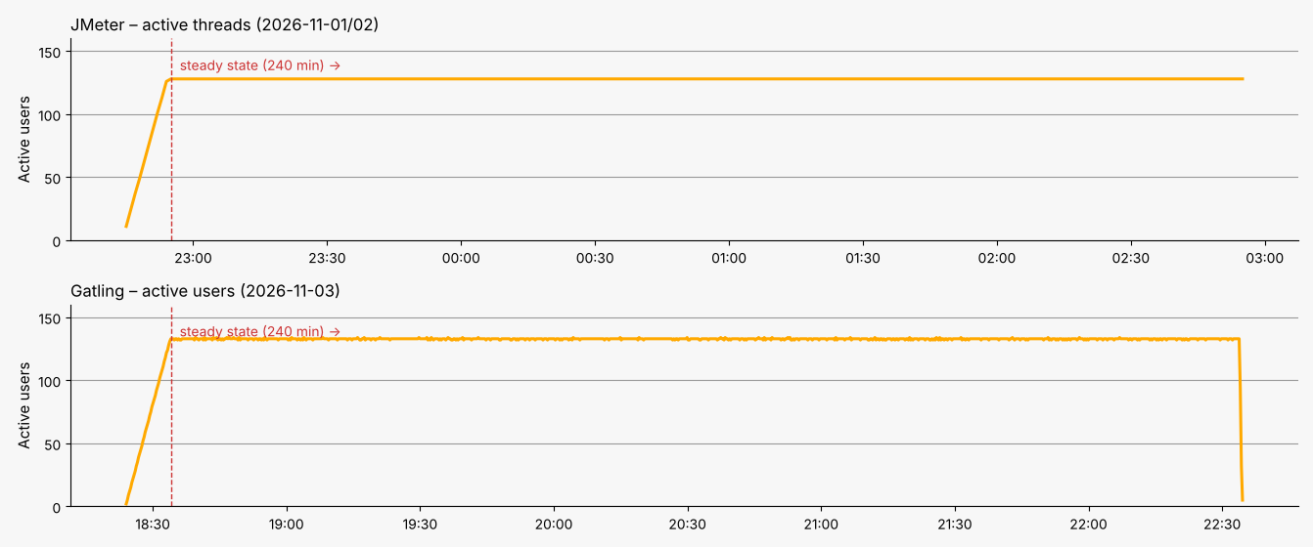Figure 3.1 – Steady-State Load Profile
To ensure a rigorous evaluation of long-term stability, the test was executed over an extended duration of 4 hours under a constant load at approximately 80% of the predetermined system saturation point. Based on prior capacity test results, where saturation was established at roughly 160 virtual users, the target load for this evaluation was fixed at 128 concurrent virtual users. Unlike short-duration performance runs that only capture initial baseline behavior, this prolonged exposure was specifically designed to surface time-dependent degradation, such as memory leaks, thread starvation, connection pool exhaustion, and uncollected garbage collection overhead.

4. Test Start and End Date/Time
Table 4.1 – Capacity Test Start/End Dates and Execution Duration
Tool | Start | End | Duration
JMeter | 2026-11-01 22:55:00 | 2026-11-02 02:55:00 | 240 min
Gatling | 2026-11-03 18:34:00 | 2026-11-03 22:34:00 | 240 min

5. Link to the Test HTML Reports
The detailed results of both tests are stored in the html-reports directory, with one sub-folder per tool.
- JMeter (StabilityTest_20261101-2245):
  - report_steady/index.html: the generated HTML dashboard for the 240-minute steady-state window (built from results_steady.jtl).
  - results.jtl: the raw results file of the whole run (including ramp-up); results_steady.jtl: its steady-state part.
  - steady_summary.csv, soak_trend.csv, soak_verdict.csv: per-transaction summary, 15-minute trend and degradation verdict.
  - jmeter.log, jmeter_gc.log and console.log: the execution logs.
- Gatling (StabilityTest_Gatling_20261103162355075):
  - index.html: the generated HTML report, with per-request and per-group pages.
  - simulation.log: the raw results file.

6. Detailed results
Both tools show practically identical picture. JMeter processed 510,734 top-level transactions in the steady-state window at 35.5 transactions/s with error rate 0.017%. Gatling processed 546,632 requests in 4 h 10 min 45 s (mean 36.3 req/s) with 0 failed requests; its 12 percentile assertions (95th percentile ≤ 2.5–4 s per request) all passed.
Throughput. In both runs the throughput is flat at about 35–36 req/s (peaks up to ≈ 37.5 req/s, dips down to ≈ 33.5 req/s) for the whole duration and does not drop even when response times grow at the end of the test. This confirms that the load model held the target load and that the generators were not the limiting factor.
Response time. The pct90 response time stays at ≈ 100–130 ms for roughly the first three hours and then starts to rise gradually: in JMeter from about 23:30 (≈ 3 h in), reaching 250–350 ms by the end; in Gatling from about 19:30, with growing spikes up to 400–490 ms in the last 30 minutes of the run. The same growth pattern in two independent tools points to the behaviour of the application under test rather than to a tool artefact.
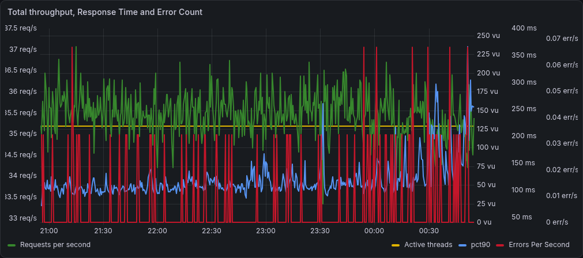
Figure 6.1 – JMeter: total throughput (RPS), pct90 response time, active threads and errors per second
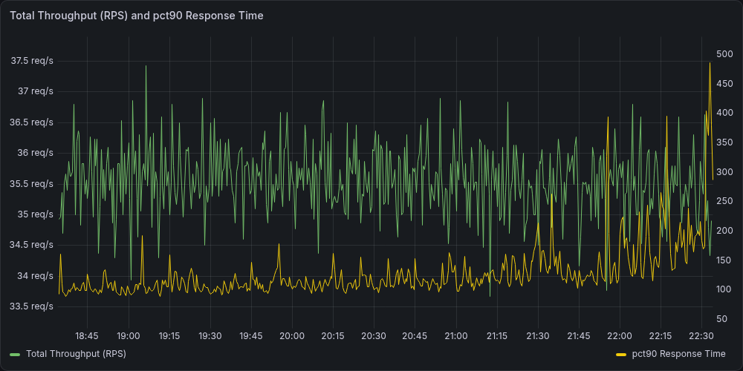
Figure 6.2 – Gatling: total throughput (RPS) and pct90 response time
Errors. JMeter registered 87 failed samples out of 510,734 (0.017%): 83 × NoHttpResponseException, 2 × java.net.SocketException and 2 × HTTP 500. They are isolated (≤ 0.07 errors/s), spread over the whole run, mostly on navigation and product-page steps (NavigateToTables 19, OpenTableProductCard 17), and become more frequent in the last hour, simultaneously with the latency growth. Gatling did not register a single failed request.

6.1 Response Time Behavior
Table 6.1 – Distribution of top-level transaction response times (JMeter)
Range | Count | Share
< 100 ms | 383,889 | 75.16%
100–200 ms | 103,956 | 20.35%
200–500 ms | 20,242 | 3.96%
500 ms–1 s | 2,075 | 0.41%
1–2 s | 505 | 0.10%
> 2 s | 67 | 0.01%

Table 6.1b – Distribution of response times (Gatling)
Range | Count | Share
< 800 ms | 512,024 | 99.87%
800 ms – 1.2 s | 410 | 0.08%
≥ 1.2 s | 186 | 0.04%
Failed | 0 | 0.00%

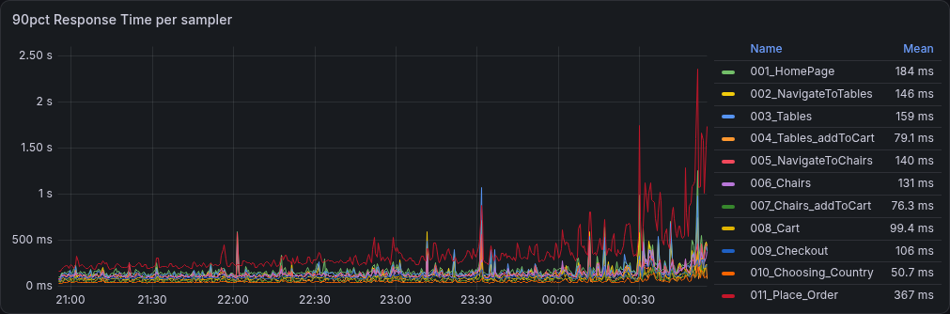
Figure 6.3 – JMeter: pct90 response time per sampler
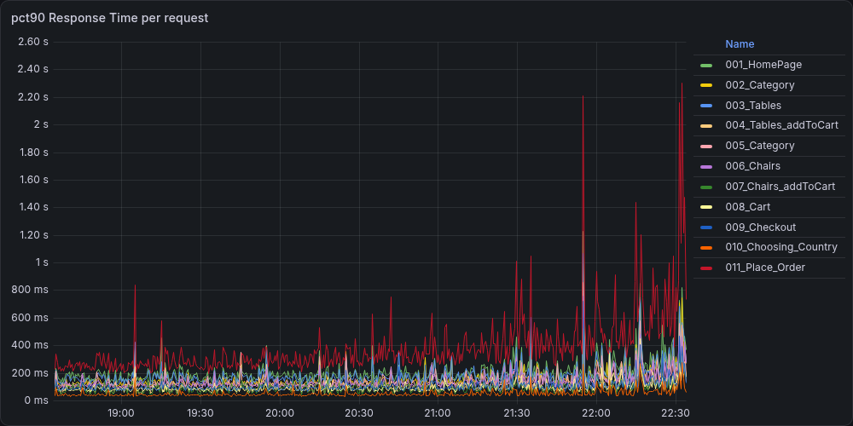
Figure 6.4 – Gatling: pct90 response time per request
In JMeter 95.5% of transactions complete in under 200 ms (75.16% under 100 ms), 99.5% in under 500 ms, and only 572 transactions (0.11%) took longer than 1 s; 67 transactions exceeded 2 s (maximum 5,045 ms, SubmitOrder). Aggregated sampler statistics for the steady state: average 89 ms, pct90 147 ms, pct95 192 ms, pct99 370 ms. Gatling confirms this: 99.89% of requests are faster than 800 ms, 0.07% (410) fall into 800–1200 ms and 0.03% (186) are slower than 1.2 s; mean 83 ms, median 72 ms, 95th percentile 165 ms, 99th percentile 315 ms, maximum 3,421 ms. Differences between the tools of a few milliseconds are explained by the different measurement points (JMeter transaction vs. Gatling request) and different time windows.
Transaction Performance Trends: Page-loading steps proved to be the slowest standard operations across both load generators, while intermediate actions like adding items to the cart, viewing the cart, checking out, and selecting a country remained fast and lightweight. The sole significant outlier was the final order submission step, which recorded the highest average latencies, percentiles, and peak spikes, accounting for the vast majority of high-latency requests recorded during the tests.
System Degradation Patterns: The prolonged stability evaluation revealed a system-wide performance degradation trend. While response times remained relatively steady through the first three hours, latency growth accelerated markedly in the final hour. Order submission experienced the most severe performance decay, though high-percentile latencies increased simultaneously across all transactional steps. Because this degradation affected every workflow concurrently rather than being isolated to a single endpoint, it points to a shared server-side bottleneck—such as database lock contention, application worker thread exhaustion, or cache saturation—requiring targeted backend container profiling to diagnose.

6.2 Throughput Behavior
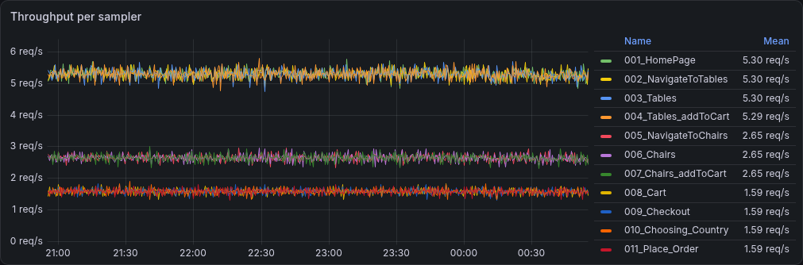
Figure 6.5 – JMeter: throughput per sampler
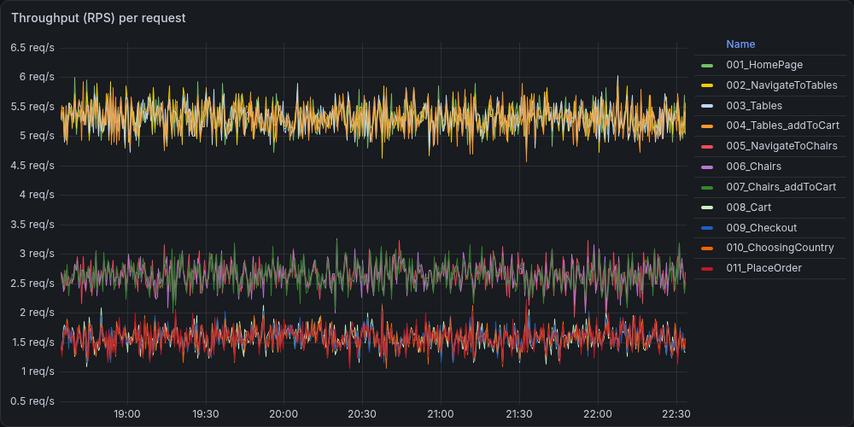
Figure 6.6 – Gatling: throughput per request
The request mix is exactly the one defined in the scenario and is stable for the whole run in both tools. JMeter: 5.30 req/s for the home page, navigation, product card and table add-to-cart; 2.65 req/s for the chair branch (50% of iterations); 1.59 req/s for cart, checkout, country selection and order placement (≈ 30% of iterations). Gatling shows the same proportions (5.20 / 2.59 / 1.55 req/s; 78,263 iterations, 39,015 with chairs, 23,307 placed orders). The lines of each group practically coincide and have no downward trend, i.e. the increase in response time at the end of the test did not reduce the delivered load, and no step was throttled or starved. About 22.8–23.3 thousand orders were created during each run.

6.3 Conclusions
Throughout the 240-minute test duration, both execution runs demonstrated highly consistent workload generation, maintaining a stable total throughput of approximately 35.5 req/s without any observable throughput degradation. The per-transaction load distribution remained balanced and identical across both testing platforms, confirming equivalent operational pressure throughout the evaluation.
System response times exhibited a clear two-phase pattern. During the initial three hours, performance remained exceptionally stable, with overall average response times and high percentiles staying flat. However, noticeable latency growth emerged in the final 60 to 90 minutes across both tools. While lightweight operations maintained acceptable response times within SLA limits, complex transactions—most notably order submission—experienced significant degradation in their higher percentiles during the final phase of the test.
Overall execution stability remained high, with error rates staying negligible to non-existent and system throughput remaining unaffected despite the late-stage latency increase.

6.4 System Resource Utilization

6.4.1 CPU utilization
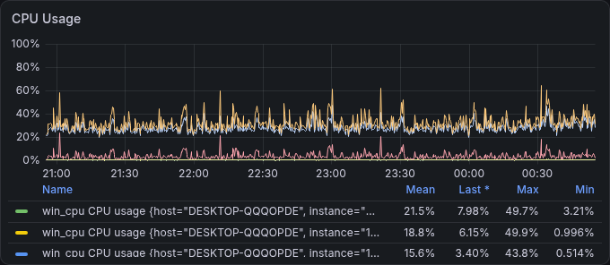
Figure 6.7 – JMeter: System Host CPU Utilization Breakdown
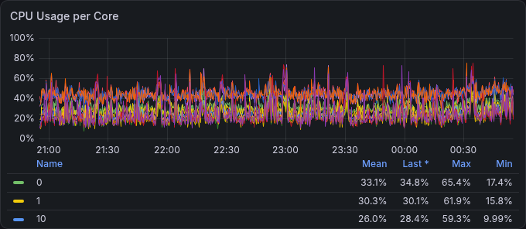
Figure 6.8 – JMeter: System Host CPU Usage per Core
During the JMeter run the overall CPU usage was about 32%, and during the Gatling run about 30.5% (the “CPU usage” gauge on the overview dashboards). In both cases the host stayed far below the level (70–80%) at which a load generator starts to influence the measured response times.
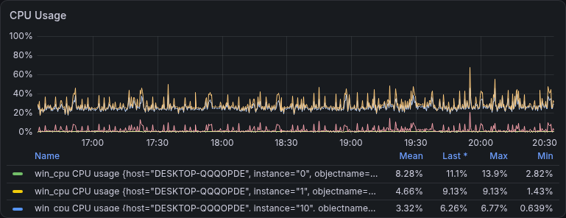
Figure 6.9 – Gatling: System Host CPU Utilization Breakdown
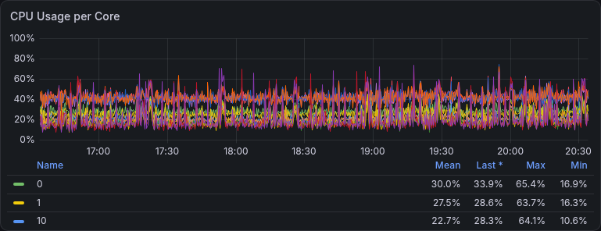
Figure 6.10 – Gatling: System Host CPU Usage per Core
The minimum values are 10–17% for all cores. The load is spread over many cores, with core 0 slightly busier than the others. This is typical for a Windows host that also runs a browser, the Docker engine and monitoring in addition to the generator. The short peaks of up to 60–65% last seconds and are not sustained.
The monitoring agent (Telegraf) used on average 3–5% of one core, with bursts of up to about 12.5% (Gatling) and 15% (JMeter). The java process itself consumed on average 9.2% (max 24.9%) with JMeter and 4.2% (max 13.5%) with Gatling. Gatling is therefore about twice as light on CPU for the same load of ≈ 35.5 req/s, which is consistent with its asynchronous, non-blocking model compared with JMeter’s thread-per-user model (128 threads).
In both runs the CPU curves are flat for the whole 4 hours: there is no upward trend, no saw-tooth and no sign of throttling or a runaway process. Short peaks appear near the end of the tests (around 00:35 in JMeter and around 19:50 in Gatling) and coincide with spikes of the pct90 response time. They are brief and the mean CPU level does not change, so they cannot explain the sustained latency growth.
So, CPU was not a bottleneck on the load-generator side in either test. The utilization was moderate (≈ 30%), evenly distributed and constant over time. The growth of response times in the last hour of each run should therefore be attributed to the system under test and not to a lack of CPU on the generator.

6.4.2 Memory utilization and paging
The “Memory usage” panel stays almost constant: JMeter mean 72.9 (66.1–80.5), with a slow rise of about 10 units over 4 hours and small steps around 23:00 and 00:30; Gatling mean 59.9 (57.9–63.4), practically flat. Free memory at the end was 7.1 GB during the JMeter run and 11.5 GB during the Gatling run. The difference between the runs is explained by the heavier JVM of JMeter and by other applications running on the same workstation; in both cases there are no signs of memory exhaustion.
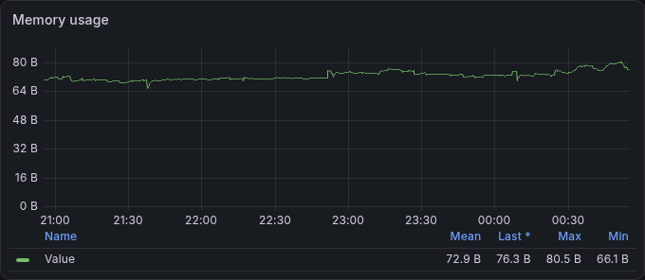
Figure 6.11 – JMeter: System Host Memory Utilization Trend
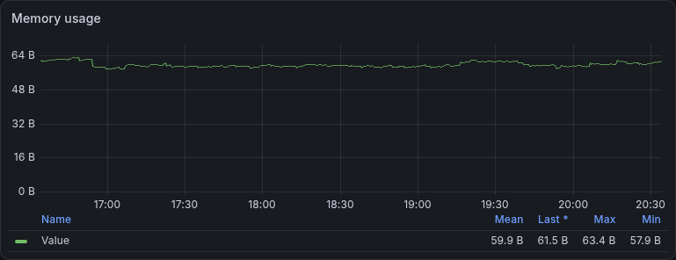
Figure 6.12 – Gatling: System Host Memory Utilization Trend
Page faults average 5.7 K/s for JMeter (peak 52 K/s) and 4.5 K/s for Gatling (peak 39 K/s); demand-zero faults 3.3 K/s vs. 2.8 K/s; cache faults ≈ 200/s in both. Short spikes are periodic and are not accompanied by throughput or latency drops, so they reflect normal working-set activity of the OS and applications, not swapping under memory pressure.
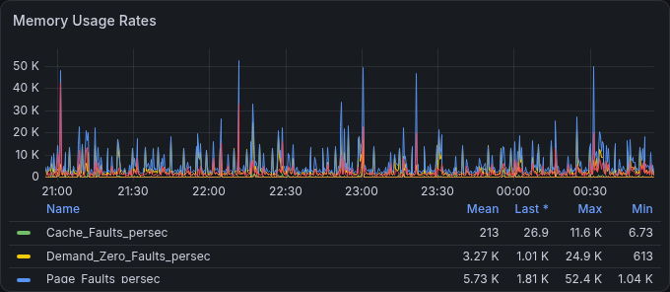
Figure 6.13 – JMeter: System Host Memory Paging & Fault Rates
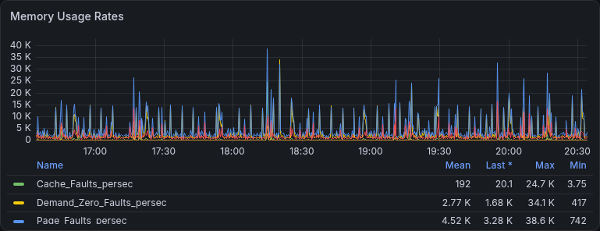
Figure 6.14 – Gatling: System Host Memory Paging & Fault Rates

6.4.3 Disk and network
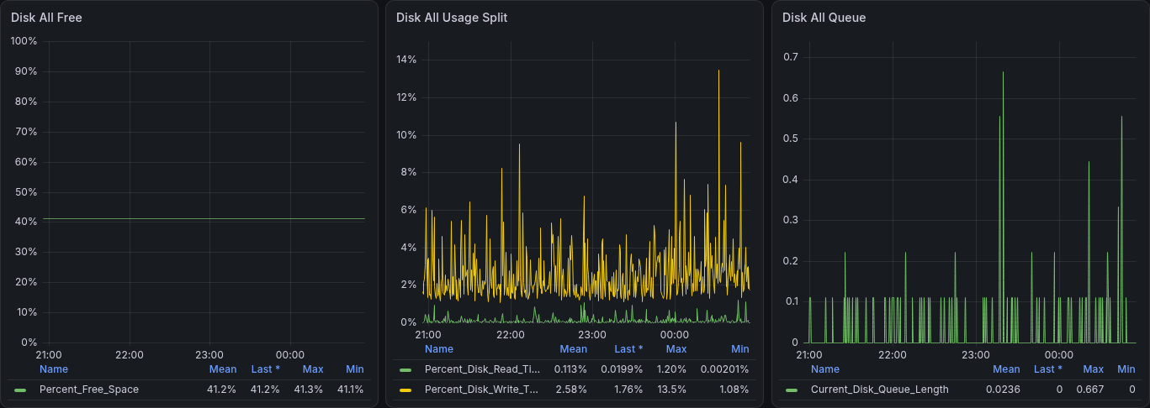
Figure 6.15 – JMeter: System Disk activity
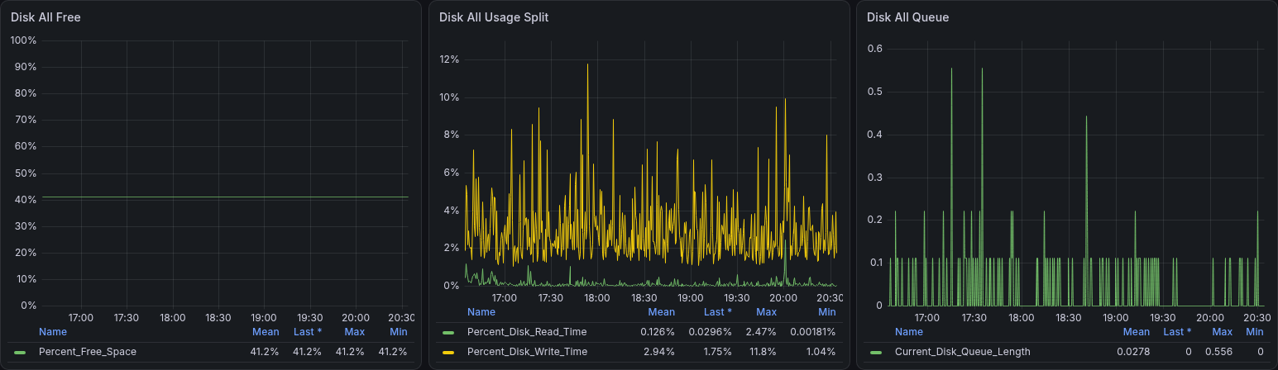
Figure 6.16 – Gatling: System Disk activity
Free space is constant at 41.2% in both runs. Disk write time averages 2.6% (max 13.5%) for JMeter and 2.9% (max 11.8%) for Gatling; read time is ≈ 0.1%. The disk queue length averages 0.02–0.03 with maximum 0.67 (JMeter) and 0.56 (Gatling), i.e. it practically never exceeds one pending operation. Disk activity is caused mostly by logging results (JTL/simulation.log) and the Docker containers; it is low and stable and does not limit the test.
Network traffic of the host is low (the network interface panels on the dashboards show only short peaks of up to ≈ 4 MB/s for JMeter and ≈ 160 kB/s for Gatling) and is far from the capacity of the adapter.

6.4.4 Load generator health
The JMeter JVM uses on average 9.2% CPU (max 24.9%), has a working set of ≈ 2.8 GB, private bytes ≈ 4.6 GB, ≈ 1.67 K handles and a stable number of threads (peak ≈ 147). The heap oscillates in a regular saw-tooth between ≈ 5% and 30% of the maximum (≈ 8 GB) and returns to the same base level after every collection, so there is no memory leak. Garbage collection runs regularly (about 0.03 collections per sampling interval); GC time per interval is typically 0.3–0.6 s with isolated peaks of about 1 s, which is negligible against a four-hour run.
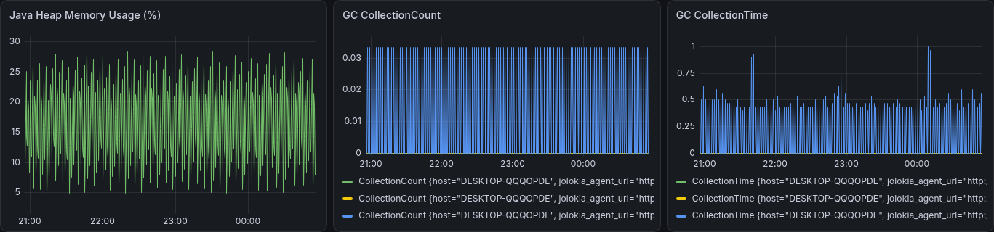
Figure 6.17 – JMeter: JVM heap usage and garbage collection
The Gatling JVM is much lighter: mean CPU 4.2% (max 13.5%), working set 218–540 MB (decreasing after the initial warm-up), private bytes ≈ 0.6 GB, ≈ 1.05 K handles, 11 threads. After a single GC at the start of the run the heap grows linearly from ≈ 0.5% to ≈ 3.1% of the maximum without any further garbage collection; this is the expected accumulation of collected statistics and is far from any limit. GC pauses are therefore not a factor for Gatling measurements.
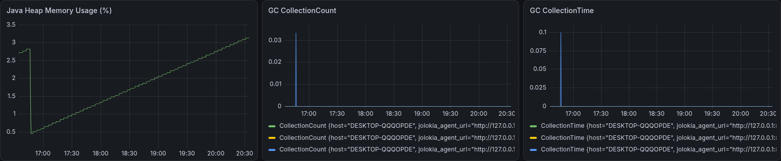
Figure 6.18 – Gatling: JVM heap usage and garbage collection
Both generators operated with a large reserve of CPU, memory, disk and JVM resources, and the delivered throughput was constant. Consequently, the growth of response times in the last hour of each run (+35% on average, +76% in p95 in JMeter) is attributable to the system under test and not to the measurement tools. The application survived four hours at ≈ 35.5 req/s with a negligible error rate (0.017% in JMeter, 0% in Gatling) and with 99.5% of transactions below 500 ms, but the steadily growing latency – most noticeable for order placement – is a sign of progressive degradation that should be investigated (database growth, caches, PHP/DB connection handling) before the stability criterion “no degradation over time” can be considered fulfilled.

6.4.5 Conclusion
Neither the test host nor the load generators came close to a resource limit. Host CPU stayed at ≈31% (per-core peaks ≈65%), RAM at 60–73% on average, disk time below 3% on average with a queue below 0.7, and the network was almost idle because the traffic goes through the loopback interface. The JMeter and Gatling java.exe processes are stable (no memory growth, regular GC), so the load generators did not distort the measurements. The only trends that coincide with the late response-time degradation are the slowly rising RAM usage in the JMeter run and the higher disk write rate at the end of both runs; as the web application and database run on the same host, further per-process monitoring is needed to attribute them.

Stability test conclusion
The 240-minute stability test at 125 virtual users was completed by both tools (JMeter and Gatling) with consistent results: stable throughput (≈35.5 req/s), 0.017% / 0% errors, APDEX 0.997, no memory leaks and no resource saturation; all SLAs are met.
The test also revealed a gradual response-time degradation in the last 60–90 minutes (95th percentile of all transactions +76%, Submit Order 95th percentile 254 → 899 ms) together with a slight increase of transport errors. The system can therefore be considered stable for ≈3 hours of continuous load and acceptable for 4 hours, with the risk that the degradation continues in a longer run.

UI test

1. Purpose of the test
The purpose of the UI test was to measure the client-side performance of the web application as experienced by a single user in the main business flow. The test checks the Core Web Vitals and related Lighthouse metrics of every step against the proposed Service Level Agreements (SLAs).

2. Summary of Results
The goal of the UI test was achieved. All 10 runs of the scenario completed successfully, and every measured metric met its proposed SLA with a wide margin. Only the page-load step is scored below 100 (median 92); all six interaction steps scored 100 in every run.
Table 2.1 – UI Test Results Summary
Metric | Value
Successful runs | 10 of 10 (no failed runs)
First Contentful Paint (FCP) | Median 840 ms (min 818 ms, max 877 ms)
Largest Contentful Paint (LCP) | Median 1,672 ms (min 1,527 ms, max 1,855 ms)
Speed Index | Median 1,294 ms (min 1,210 ms, max 1,818 ms)
Total Blocking Time (TBT) | 0 ms on page load; median 0–24 ms on the six timespan steps (worst single run 37 ms)
Cumulative Layout Shift (CLS) | Median 0.002 on page load; at most 0.031 in any run (step Click Place an order)
Time to Interactive (TTI) | Median 1,110 ms (min 1,081 ms, max 1,130 ms)
Performance score, page load | Median 92 (min 90, max 93)
Performance score, other steps | 100 in all 60 step executions (6 steps × 10 runs)

2.1 Client-Side Performance Metrics (Web Vitals)
As part of the UI testing, the order-flow scenario was executed 10 times in a row with Google Lighthouse. The first step (Open the application) is a navigation, so Lighthouse reports the full set of metrics for it. The other six steps are timespans, for which Lighthouse reports only Total Blocking Time (TBT), Cumulative Layout Shift (CLS) and the performance score.
• Loading Performance: The Largest Contentful Paint (LCP) remains well within the "good" threshold, while the First Contentful Paint, Speed Index, and Time to Interactive show fast, highly stable page rendering with only minor variance during initial cold starts.
• Main-Thread Interactivity: Total Blocking Time (TBT) is virtually non-existent during initial loads and remains exceptionally low across all interactive steps, indicating that the main thread stays responsive under user actions.
• Visual Stability: Cumulative Layout Shift (CLS) is negligible across almost all pages. A slight, bimodal shift is observed specifically during the "Click Place an order" step due to dynamic content injection, but even these peak variations remain safely below the strict warning threshold.

2.2 Service Level Agreements (SLA) Definition
I propose the following Service Level Agreements (SLAs), based on the “good” thresholds of Core Web Vitals and Lighthouse for each metric:
Table 2.2 – Service Level Agreements (SLA) Compliance & Fulfillment
Metric | Target SLA | Test Data | Fulfillment Status
First Contentful Paint | ≤ 1,800 ms | Median 840 ms; worst run 877 ms | Met
Largest Contentful Paint | ≤ 2,500 ms | Median 1,672 ms; worst run 1,855 ms | Met
Speed Index | ≤ 3,400 ms | Median 1,294 ms; worst run 1,818 ms | Met
Total Blocking Time | ≤ 200 ms | Page load 0 ms; timespan steps: median ≤ 24 ms, worst run 37 ms | Met
Cumulative Layout Shift | ≤ 0.1 | Median ≤ 0.017 on every step; worst run 0.031 | Met
Time to Interactive | ≤ 3,800 ms | Median 1,110 ms; worst run 1,130 ms | Met
Performance score | ≥ 90 | Page load: median 92, min 90; all other steps: 100 | Met

2.3 Conclusions and Areas of Concern
All proposed SLAs are fulfilled, and the results are highly repeatable: the standard deviation is 17 ms for FCP, 88 ms for LCP and 15 ms for TTI, and no run failed. No blocking defects were found. The following points are worth attention:
Layout shift on Click Place an order. In half of the runs this step produces a CLS of 0.031, ten to fifteen times higher than on the other steps. It is within the SLA, but it shows that content moves after the click (for example, the order form appearing without reserved space) and is easy to remove.
Gap between FCP and LCP. The largest element is rendered about 0.8 s after the first paint. LCP is the metric closest to its limit (67%), and is therefore the best candidate for optimization if the SLA is tightened.
Limits of the test. The test uses a single user and 10 runs, so it describes the front-end behavior of the application without concurrent load and cannot be used to judge capacity. Timespan steps have no FCP, LCP, Speed Index or TTI, so only TBT and CLS can be assessed for them.

3. Load Profile
One Lighthouse user flow is executed at a time, sequentially, 10 times (10 loops). Each loop performs the 7 steps of the order-flow scenario, in a fixed order, in a fresh browser session of the load-generator host. The 10 loops took about 15 min 41 s in total, i.e. roughly 94 s per loop including the Lighthouse start-up and report generation.

4. Test Start and End Date/Time
Start: 2026-11-04 11:27:46. End: 2026-11-04 11:43:27. Duration: about 15 min 41 s.

5. Link to the Test HTML Reports
The detailed results of the UI test are stored in the html-reports directory, with the UITest sub-folder: 10 reports for 10 runs (performance-testing-essentials-run1.report.html … run10.report.html) + summary report (performance-testing-essentials.summary.html).

6. Detailed results

6.1 Web Vitals Summary over all runs
Figure 6.1 summarizes all 10 runs for each step and metric (median, mean, minimum, maximum and standard deviation).
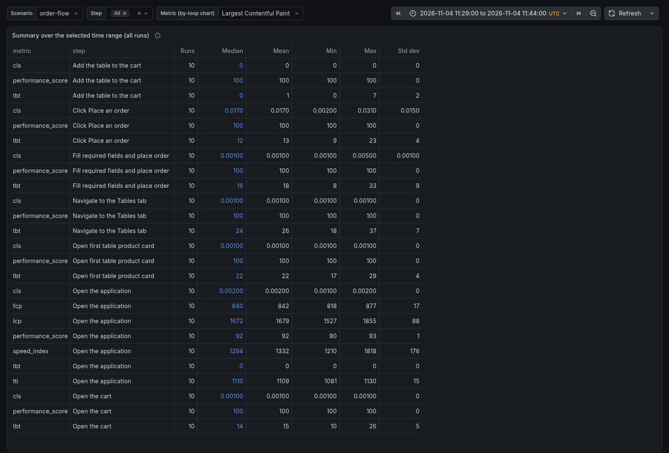
Figure 6.1 – Summary over all runs

6.1.1 LCP and FCP by loop
LCP stays between 1.53 s and 1.86 s in all loops, with the highest value in loop 07 and the lowest in loop 03. FCP is almost flat (0.82–0.88 s), with the highest value in loop 09.
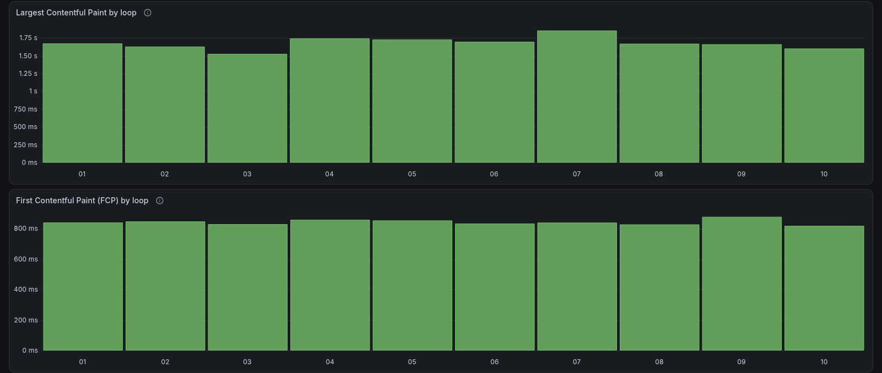
Figure 6.2 – Largest Contentful Paint and First Contentful Paint by loop

6.1.2 TBT, CLS, Speed Index and performance score
TBT of all steps stays under 40 ms. The CLS chart shows the repeating peaks of 0.031 for Click Place an order (loops 1, 4, 5, 9 and 10), while all other steps stay close to zero. Speed Index is highest in loop 1 (about 1.8 s) and then settles at 1.2–1.3 s. The performance score is at the maximum for all steps except Open the application (90–93).
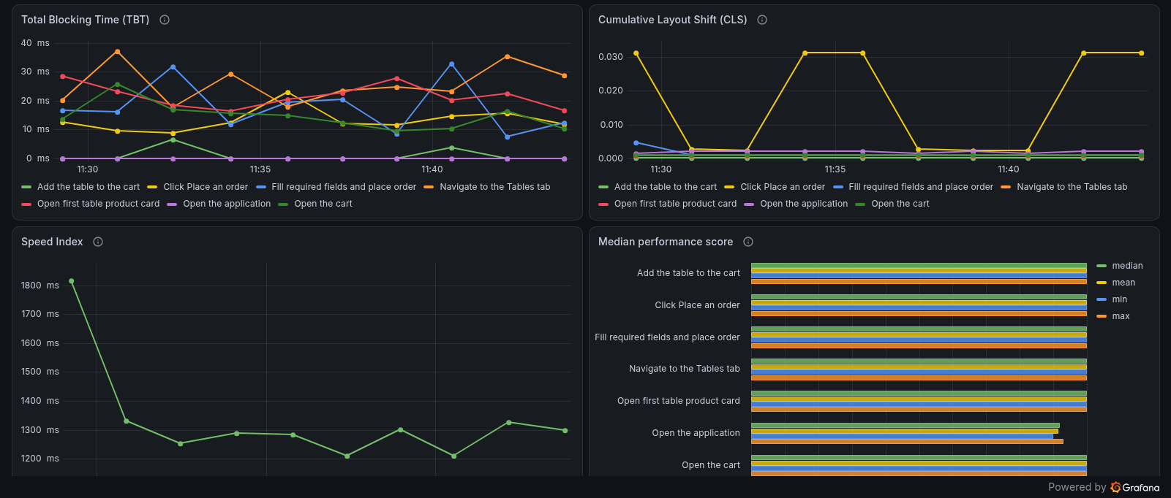
Figure 6.3 – TBT, CLS, Speed Index and median performance score

6.1.3 Conclusion
The Lighthouse data is consistent across runs (for example, a median LCP of 1,672 ms and a median performance score of 92 for the page load). The application is fast on first load and responsive in every interaction step; the only visible effect is the intermittent layout shift on the Place an order click.

6.2 Load generator host monitoring

6.2.1 CPU utilization
CPU usage was moderate: 18.8% at the last sample, with means of 11.5–27.3% for the logical CPUs shown and peaks of 50.7–56.2%. The CPU usage per core had a mean of 6.8–15.4% and peaks of 35.8–37.9%. The Telegraf agent itself used up to about one third of a CPU in a single short spike.
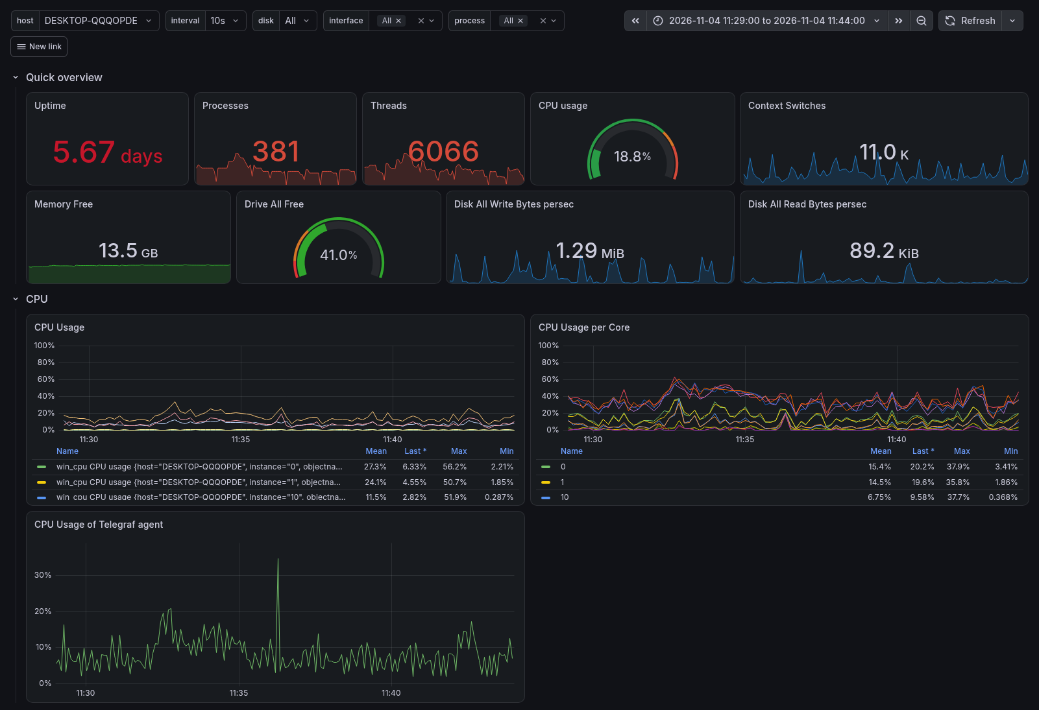
Figure 6.4 – Quick overview and CPU utilization of the load-generator host

6.2.2 Memory utilization and paging
Memory usage is flat during the whole test (the panel shows 54.7–60.9, with a mean of 56.7; the unit label of this panel appears to be set incorrectly), and the Memory Free tile shows 13.5 GB. Page faults (mean 18.8 K/s, maximum 43.7 K/s) and demand-zero faults (mean 15.6 K/s) are periodic and match the start of each loop. Context switches (mean 12.0 K/s) and system calls (mean 79.4 K/s, maximum 222 K/s) show the same periodic pattern.
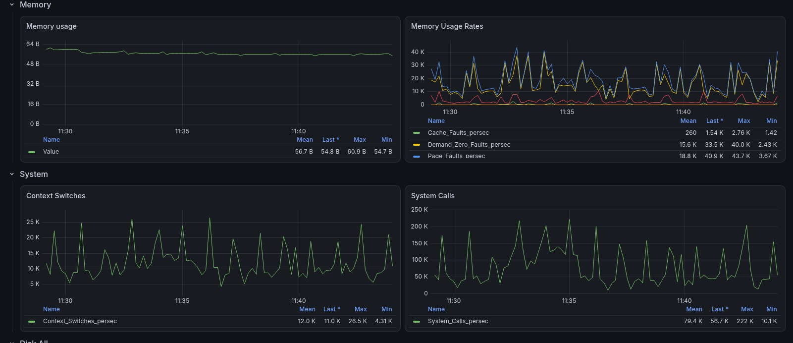
Figure 6.5 – Memory usage, paging rates, context switches and system calls

6.2.3 Disk and network
Free disk space is constant at 41.0%. The disk was busy for only 0.65% of the time on reads (maximum 2.75%) and 4.46% on writes (maximum 12.1%); the disk queue length averaged 0.13 and never exceeded 1. Network traffic is low: the Wi-Fi adapter received 2.5 kB/s on average with peaks of about 30 kB/s, and the wired adapter was idle.
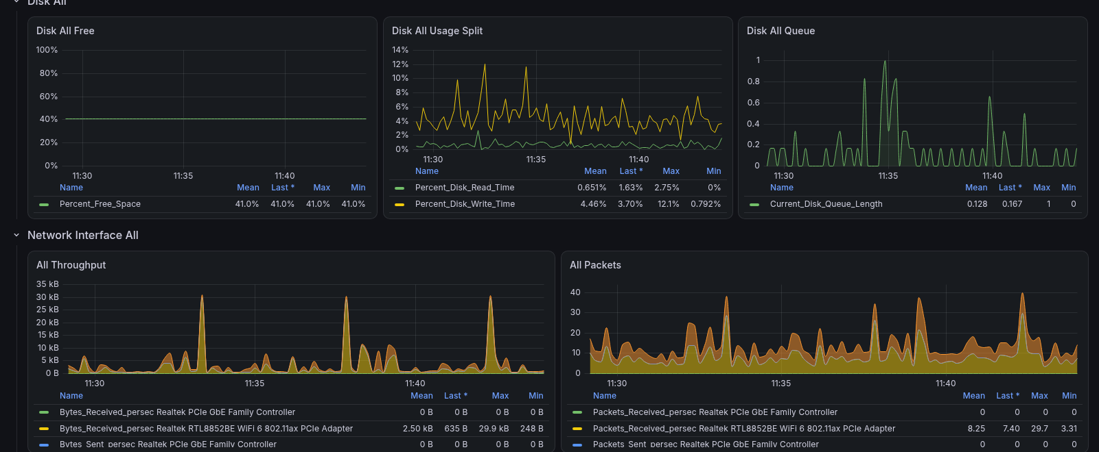
Figure 6.6 – Disk and network interface utilization

6.2.4 Load generator health: test processes
The per-process panels show ten similar peaks, one per loop. Node.js (which runs the Lighthouse scenario) reached up to 202% processor time (more than one core), 833 MB of private bytes and 742 MB of working set at the peaks, and fell back after each loop. Chrome used 5.7% of a CPU on average (maximum 35.0%) and 56–94 MB of working set. Handle counts are stable (about 360–460) and the node.exe thread count varies between about 5 and 17. The last peak at the end of the test corresponds to the generation of the summary report. (The section of the dashboard is named java.exe, but the panels show the node.exe process.)
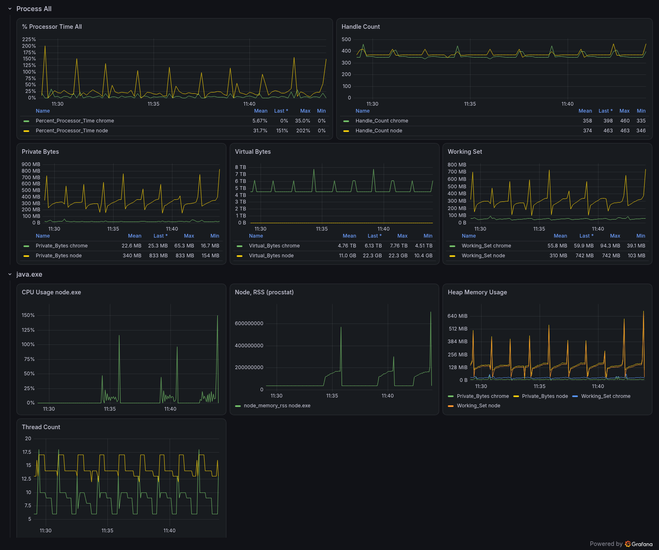
Figure 6.7 – Process utilization (Chrome, Node.js) and node.exe details

6.2.5 Conclusion
The load generator had enough spare capacity: CPU peaks stayed near 56% on a single logical CPU, memory was stable, and disk and network were practically idle. Resource consumption follows the loops of the test and returns to the baseline after each of them, with no growth that would point to a leak. The host can therefore be considered a non-limiting factor, and the Lighthouse results are not expected to be distorted by it; the single higher Speed Index in loop 1 is the only visible deviation and is not correlated with any host spike.

7. UI test conclusion
The UI test of the order-flow scenario was successful: 10 of 10 runs completed, and all 7 proposed SLAs were met. The page load scores 92 (FCP 840 ms, LCP 1,672 ms, Speed Index 1,294 ms, TBT 0 ms, CLS 0.002, TTI 1,110 ms), and all six interaction steps score 100 with TBT up to 37 ms and CLS up to 0.031. The results are stable (standard deviation of LCP 88 ms), and the load-generator host was not a bottleneck.

Recommendations for Fixes, Improvements, and Investigation
To ensure stable system scaling beyond the current limits (over 160 virtual users and 41.5 RPS) and prevent response time degradation for critical transactions, I propose the following:

PHP-FPM and Web Server (Nginx / Apache) Optimization
PHP-FPM Worker Pool Tuning:
- Switch the process management mode from dynamic to static, or carefully optimize the pm.max_children, pm.start_servers, pm.min_spare_servers, and pm.max_spare_servers parameters based on the available RAM to avoid the overhead of constant process creation and destruction during peak loads.
Web Server (Nginx) Tuning:
- Optimize fastcgi_connect_timeout, fastcgi_send_timeout, and fastcgi_read_timeout parameters to ensure stable processing of long-running requests.
- Configure effective static content caching (images, styles, scripts) at the Nginx level using Expires/Cache-Control headers, which will reduce the total number of requests sent to PHP-FPM.

2. Caching and Database Optimization (WooCommerce / WordPress)
Implementation of Object Caching:
Integrate Redis or Memcached as the backend for WordPress object caching to minimize the number of repetitive, heavy SQL queries to the database (e.g., caching options, product metadata, and cart states).
MySQL Database Query Optimization:
- Audit slow SQL queries (Slow Query Log) during peak JMeter test loads, especially within the wp_postmeta, wp_woocommerce_sessions, and wp_options tables.
- Ensure the presence of necessary indexes for frequently accessed fields.
- Move WooCommerce sessions (wp_woocommerce_sessions) to in-memory storage (Redis), as standard session storage in the database table creates significant table/row locks during checkout.

3. Application-Level Profiling (Home Page and Checkout)
The results point first at the home page. In both tools 001_HomePage produces the most errors: 4,273 in JMeter and 2,365 in Gatling, several times more than any other step. In JMeter its median response time (~4.8 s) is also far above the others (~100 ms or less).
Profile the home page (Xdebug, New Relic or a similar tool) to find slow plugins, widgets, queries and hooks.
After that, profile the checkout (woocommerce_checkout_process, woocommerce_payment_complete). Under saturation its response times grow similarly to other steps (pct90 ~5 s), so it is a secondary suspect.

4. Further Investigation and Infrastructure Monitoring
- Root cause analysis: review the application, PHP-FPM, Nginx and MySQL logs for the period around ≈ 160 VU (saturation) and ≈ 270 VU (instability). Compare them with the error types seen in the tests (timeouts, HTTP 500, failed assertions).
- Monitor PHP-FPM active/idle workers, listen queue, max-children reached, MySQL active connections, lock waits and slow queries in the same timeline as p95/p99. These metrics will reveal the transition from the healthy response-time baseline to the queueing behavior observed in the capacity test.
- Extended monitoring (Prometheus / Grafana / InfluxDB): add per-container CPU, RAM, disk I/O and network metrics for the application and database containers. Add PHP-FPM and MySQL metrics. Collect them during both the JMeter and the Gatling runs.
- Load generator isolation: the host dashboards show the load generator (java.exe) and the monitoring agent running on the same machine as the test environment. Run the generator on a separate host, or confirm that it is not limiting the results.
- Re-test after changes: repeat the capacity test with the same scenario and compare the saturation point against ≈ 160 VU and ~43 req/s.
- Auto-scaling: in a cloud deployment, horizontal scaling can help, but only if sessions and cache are shared (for example in Redis) and the database is not the bottleneck. This should come after the bottleneck is identified.

5. Frontend Performance and UI Diagnostics
To complement backend load-testing insights, frontend audits (Lighthouse/UI tests) were performed to evaluate client-side rendering efficiency, resource delivery, and visual stability. Based on the findings, the following UI-level optimizations and metric expansions are recommended:
- Render-Blocking CSS:
  - Finding: Render-blocking stylesheets (notably dashicons.min.css, contributing a potential savings of ~910 ms with a score of 0.48, where 36 KB was found to be entirely unused).
  - Action: Prevent loading unnecessary admin styles (like Dashicons) for frontend visitors, implement critical CSS inline, and defer non-critical styles.
- Static Caching:
  - Finding: Multiple static resources were detected without caching headers (cacheLifetime of 0, score of 0.07).
  - Action: Enforce strict Cache-Control and Expires headers at the Nginx level for images, CSS, and JS assets (as noted in Section 1).
- Font Delivery (Poppins):
  - Finding: Font files lacked the font-display property, resulting in a potential render delay of up to ~140 ms per file.
  - Action: Add font-display: swap and preload critical font variants.
- Responsive Images & Formats:
  - Finding: Oversized images (e.g., rendering ~600 px assets in ~213 px containers) resulted in an estimated waste of ~452 KB, with an additional ~209 KB savings potential through next-gen formats.
  - Action: Utilize proper srcset/sizes attributes, generate accurate thumbnail sizes, and convert static assets to modern formats like WebP/AVIF.
- Unused CSS:
  - Finding: Approximately 66 KB of unused CSS was identified from theme stylesheets and icon libraries.
  - Action: Audit and strip unused style rules or modularize theme asset loading.
- Unstable CLS During Order Placement:
  - Finding: Cumulative Layout Shift (CLS) fluctuates between ~0.003 and 0.031 during the "Click Place an order" step. While remaining below the strict warning threshold of 0.1, this jitter indicates dynamic elements (such as validation messages or alerts) being injected into the DOM post-click.
  - Action: Pre-allocate structural space in the markup for dynamic notifications or validation errors to completely eliminate layout shifting before it impacts user experience.
- Comprehensive Resource and Timing Metrics:
  - Action: Expand automated UI/Lighthouse data collection beyond standard scores to include total-byte-weight, total request counts, cumulative JS/CSS payload sizes, and Time to First Byte (TTFB). Tracking TTFB at the step level will directly bridge frontend observations with the backend database/PHP bottlenecks identified in the primary performance report.

Conclusion
Comprehensive performance and UI testing of the WordPress/WooCommerce application was successfully performed using JMeter and Gatling for the backend, and Lighthouse for the frontend.
- Capacity Test: The system saturates around 160 virtual users (~42 req/s) and transitions into instability around 270 VUs, where response times degrade severely and systematic errors emerge. The home page represents the primary bottleneck. As host hardware resources were not saturated, the constraint lies within the application stack.
- Response Time Test: Under a continuous 80% workload, the application processed tens of thousands of transactions with zero errors and exceptional responsiveness across all endpoints, fully satisfying all SLAs. These metrics serve as an official baseline for future software releases.
- Stability Test: Over a 4-hour continuous run, throughput remained flat with zero host-level memory leaks. However, noticeable response-time degradation occurred during the final 60–90 minutes—particularly on order submissions—indicating potential backend queuing or lock contention under sustained exposure.
- UI Test: Client-side audits confirmed strong frontend efficiency, with all core Web Vitals comfortably meeting performance thresholds. Minor layout shifts during order placement were the only notable UI observation.
Under normal operating conditions, the application performs reliably and meets all defined SLAs. Capacity limits, baseline latencies, and long-term degradation patterns are now fully documented.
Key Recommendations:
- Optimize PHP-FPM worker pools and web server parameters.
- Implement Redis/Memcached object caching and migrate WooCommerce session storage off the database.
- Audit slow SQL queries and profile the home page and checkout workflows.
- Address client-side optimizations (render-blocking CSS, static asset caching, image formats).
- Re-test post-optimization to verify capacity improvements against established baselines.
Testing Limitations: Operating all components (application, database, load generator, monitoring) on a single host prevented definitive root-cause isolation. Future testing should isolate the load generator and incorporate container-level PHP-FPM/MySQL monitoring during an extended endurance run (8–12 hours).

